**Test installation**

# C:\path\to\logstash

# C:\Devs-and-tools\install\ELK\logstash-8.2.3

# bin\logstash -e "input { stdin { } } output { stdout { } }"

[2022-12-24T11:45:39,053][INFO ][logstash.agent ] Pipelines running {:count=>1, :running_pipelines=>[:main], :non_running_pipelines=>[]}

{

"event" => {

"original" => "\r"

},

"host" => {

"hostname" => "PAR-N-PW10-5273"

},

"@version" => "1",

"@timestamp" => 2022-12-24T10:45:39.093770300Z,

"message" => "\r"

}

stdin it s a plugin

stdout is a plugin

# bin\logstash -e "input { stdin { } } output { stdout { } }"

This command Start logstash

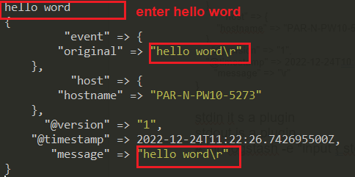

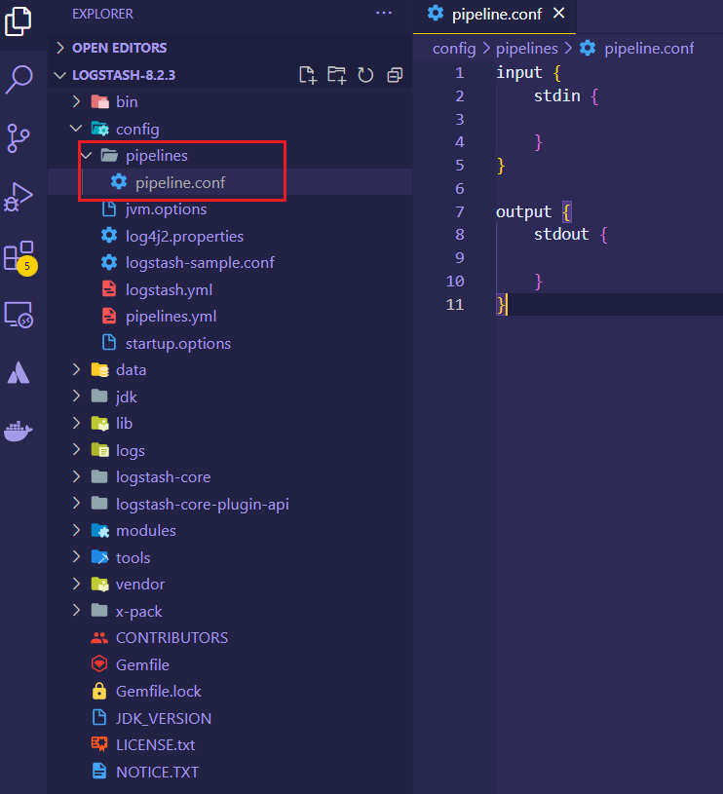

Create file pipeline.conf

Shatdown logstash

# crtl +c

# bin\logstash -f config/pipelines/pipeline.conf

In terminal -> hello word

{

"@version" => "1",

"host" => {

"hostname" => "PAR-N-PW10-5273"

},

"@timestamp" => 2022-12-24T11:40:22.190109Z,

"event" => {

"original" => "hello word\r"

},

"message" => "hello word\r"

}

Change log

pipelines/pipeline.conf

input {

    stdin {

    }

}

output {

    stdout {

        codec => rubydebug

    }

}

Hello world in terminal

hello world

{

"@version" => "1",

"@timestamp" => 2022-12-24T11:42:57.200636800Z,

"host" => {

"hostname" => "PAR-N-PW10-5273"

},

"event" => {

"original" => "hello world\r"

},

"message" => "hello world\r"

}

**Handling Json Input**

# bin\logstash -f config/pipelines/pipeline.conf

# {"amount": 10 , "quantity": 5}

{

"@version" => "1",

"@timestamp" => 2022-12-24T11:46:54.320992Z,

"host" => {

"hostname" => "PAR-N-PW10-5273"

},

"event" => {

"original" => "{\"amount\": 10 , \"quantity\": 5}\r"

},

**"message" => "{\"amount\": 10 , \"quantity\": 5}\r"**

}

Add Json to output

input {

    stdin {

        codec = json

    }

}

output {

    stdout {

        codec => rubydebug

    }

}

# { "amount" : 10 , "quantity" : 5 }

{

"@version" => "1",

"@timestamp" => 2022-12-24T11:55:55.785283200Z,

"event" => {

"original" => "{ \"amount\" : 10 , \"quantity\" : 5 }\r\n"

},

**"quantity" => 5,**

"host" => {

"hostname" => "PAR-N-PW10-5273"

},

**"amount" => 10**

}

# [ { "name" : "order1"} , { "name" : "order2"} ]

{

"host" => {

"hostname" => "PAR-N-PW10-5273"

},

"@version" => "1",

**"name" => "order1",**

"@timestamp" => 2022-12-24T11:59:48.850831700Z,

"event" => {

"original" => "[ { \"name\" : \"order1\"} , { \"name\" : \"order2\"} ]\r\n"

}

}

{

"host" => {

"hostname" => "PAR-N-PW10-5273"

},

"@version" => "1",

**"name" => "order2",**

"@timestamp" => 2022-12-24T11:59:48.850831700Z,

"event" => {

"original" => "[ { \"name\" : \"order1\"} , { \"name\" : \"order2\"} ]\r\n"

}

}

# { invalid_objet}

[2022-12-24T13:01:07,989][WARN ][logstash.codecs.jsonlines][main][4259d0c0402024cf5d9073648e96223eb80f41bd60bd4b44139d06f77f34aecf] JSON parse error, original data now in message field {:message=>"Unexpected character ('i' (code 105)): was expecting double-quote to start field name\n at [Source: (String)\"{ invalid_objet}\r\"; line: 1, column: 4]", :exception=>LogStash::Json::ParserError, :data=>"{ invalid_objet}\r"}

{

"@version" => "1",

"@timestamp" => 2022-12-24T12:01:07.992048300Z,

"event" => {

"original" => "{ invalid_objet}\r\n"

},

"tags" => [

[0] "_jsonparsefailure"

],

"host" => {

"hostname" => "PAR-N-PW10-5273"

},

"message" => "{ invalid_objet}\r"

}

**Write file output**

input {

    stdin {

        codec => json

    }

}

output {

    stdout {

        codec => rubydebug

    }

    file {

        path => "output.txt"

    }

}

# bin\logstash -f config/pipelines/pipeline.conf

# {"amount": 12 , "quantity": 5}

{

"quantity" => 5,

"@timestamp" => 2022-12-24T12:05:25.874759400Z,

"@version" => "1",

"host" => {

"hostname" => "PAR-N-PW10-5273"

},

"amount" => 12,

"event" => {

"original" => "{ \"amount\" : 12 , \"quantity\" : 5 }\r\n"

}

}

[2022-12-24T13:05:26,394][INFO ][logstash.outputs.file ][main][d0017f8243c5bc8e35a96b7cedd18ce2822a25709789bb08a94d247674fe3d9c] Opening file {:**path=>"C:/Devs-and-tools/install/ELK/logstash-8.2.3/output.txt"}**

**[2022-12-24T13:05:46,928][INFO ][log**stash.outputs.file ][main][d0017f8243c5bc8e35a96b7cedd18ce2822a25709789bb08a94d247674fe3d9c] Closing **file C:/Devs-and-tools/install/ELK/logstash-8.2.3/output.txt**

# tail -f output.txt

{"quantity":5,"@timestamp":"2022-12-24T12:05:25.874759400Z","@version":"1","host":{"hostname":"PAR-N-PW10-5273"},"amount":12,"event":{"original":"{ \"amount\" : 12 , \"quantity\" : 5 }\r\n"}}

{"quantity":8,"@timestamp":"2022-12-24T12:09:51.300413200Z","@version":"1","host":{"hostname":"PAR-N-PW10-5273"},"amount":100,"event":{"original":"{ \"amount\" : 100 , \"quantity\" : 8 }\r\n"}}

**Working with HTTP input plugin**

Send http request to logstash

input {

    stdin {

        codec => json

    }

    http {

        host => "127.0.0.1"

        port => "8080"

    }

}

output {

    stdout {

        codec => rubydebug

    }

    file {

        path => "output.txt"

    }

}

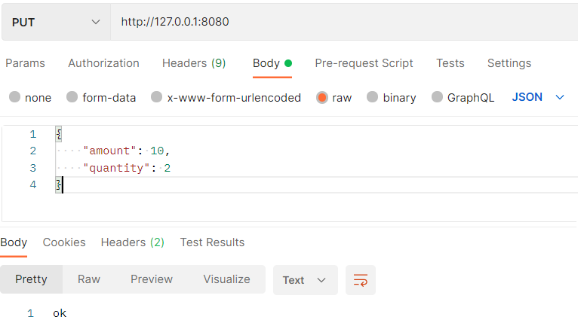

{

"http" => {

"request" => {

"mime_type" => "application/json",

"body" => {

"bytes" => "42"

}

},

"version" => "HTTP/1.1",

"method" => "PUT"

},

"event" => {

"original" => "{\r\n \"amount\": 10,\r\n \"quantity\": 2\r\n}"

},

"amount" => 10,

"url" => {

"domain" => "127.0.0.1",

"path" => "/",

"port" => 8080

},

"quantity" => 2,

"host" => {

"ip" => "127.0.0.1"

},

"@version" => "1",

"user_agent" => {

"original" => "PostmanRuntime/7.28.2"

},

"@timestamp" => 2022-12-24T12:21:44.680884400Z

}

[2022-12-24T13:21:45,876][INFO ][logstash.outputs.file ][main][bf4abb8bbbe4d815336831bfcc64ce9eade0e8a6140bbc34be0a8ccf3768e789] Opening file {:path=>"C:/Devs-and

-tools/install/ELK/logstash-8.2.3/output.txt"}

[2022-12-24T13:21:56,962][INFO ][logstash.outputs.file ][main][bf4abb8bbbe4d815336831bfcc64ce9eade0e8a6140bbc34be0a8ccf3768e789] Closing file C:/Devs-and-tools/in

stall/ELK/logstash-8.2.3/output.txt

Send request with curl

curl --location --request PUT 'http://127.0.0.1:8080' \

--header 'Content-Type: application/json' \

--data-raw '{

    "amount": 10,

    "quantity": 2

}'

**Filtering events**

input {

    stdin {

        codec => json

    }

    http {

        host => "127.0.0.1"

        port => "8080"

    }

}

filter {

    mutate {

        convert => { "quantity" => "integer"}

    }

}

output {

    stdout {

        codec => rubydebug

    }

    file {

        path => "output.txt"

    }

}

**Commun Filter options**

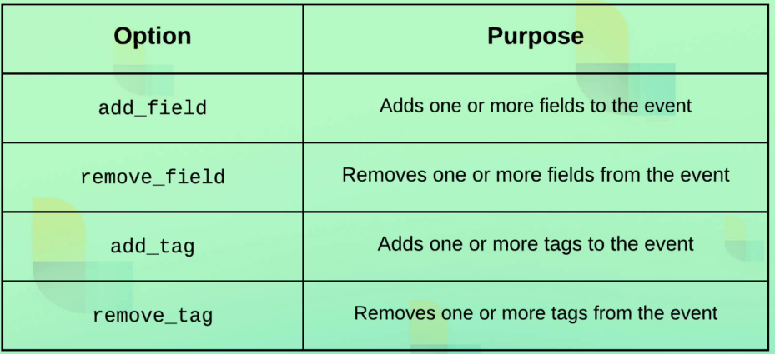

pipeline.conf

input {

    stdin {

        codec => json

    }

    http {

        host => "127.0.0.1"

        port => "8080"

    }

}

filter {

    mutate {

        remove_field => ["host"]

    }

}

output {

    stdout {

        codec => rubydebug

    }

    file {

        path => "output.txt"

    }

}

**Logstash execution model**

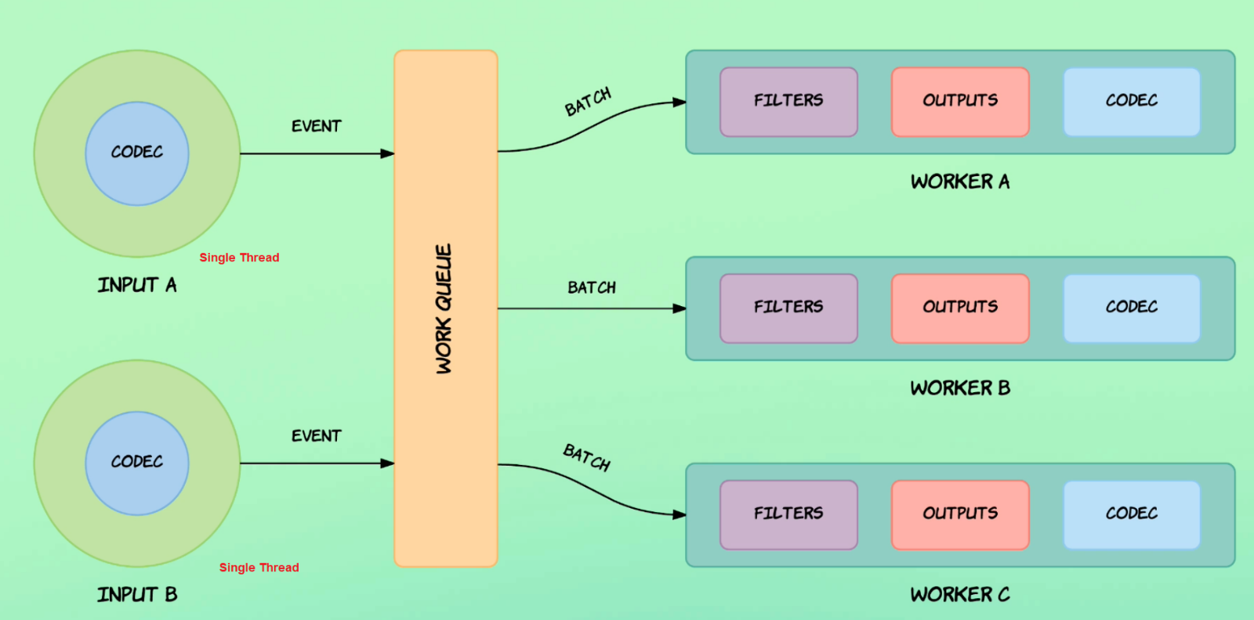

**Automatic config reload & file Input**

Live reload or automatic reload

# bin\logstash -f config/pipelines/pipeline.conf --config.reload.automatic

input {

    file {

        path => "C:/Devs-and-tools/install/ELK/logstash-8.2.3/data/event-data/apache_access.log"

        start_position => "beginning"

    }

}

output {

    stdout {

        codec => rubydebug

    }

}

# cd data\plugins\inputs\file\

# ls -al

-rw-r--r-- 1 yzaghir 1049089 0 déc. 25 11:48 .sincedb_83f0236e9ed7d8b1d7aff2637fe18c2f

# cat .sincedb_83f0236e9ed7d8b1d7aff2637fe18c2f

19267230 1 4 1591 last number represention last number p , logstash start processing from it

# rm .sincedb_* to make log to start from beginning we remove file

# ls -al

Restart logstash

# bin\logstash -f config/pipelines/pipeline.conf --config.reload.automatic

Add a new event

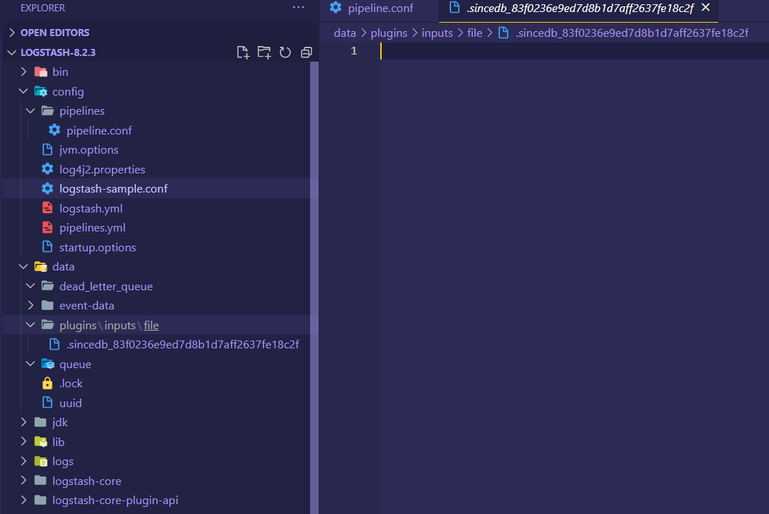# echo '91.59.108.75 - - [20/Sep/2017:20:11:43 +0200] "GET /favicon.ico HTTP/1.1" 200 7581 "https://codingexplained.com/products/view/863" "Mozilla/5.0 (Windows NT 6.1; WOW64; rv:45.0) Gecko/20100101 Firefox/45.0"' >> data\event-data\apache_access.log

Add http input

input {

    file {

        path => "C:/Devs-and-tools/install/ELK/logstash-8.2.3/data/event-data/apache_*.log"

        start_position => "beginning"

    }

    http {

    }

}

output {

    stdout {

        codec => rubydebug

    }

}

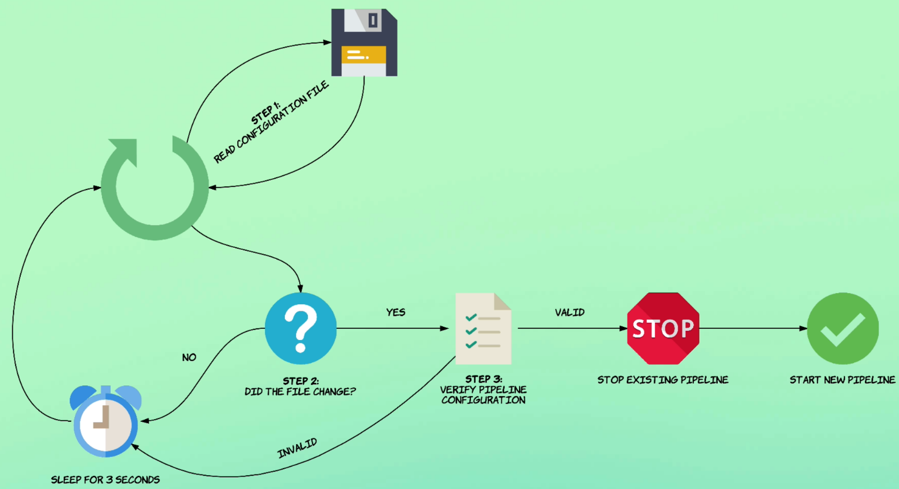

Send http event to logstash

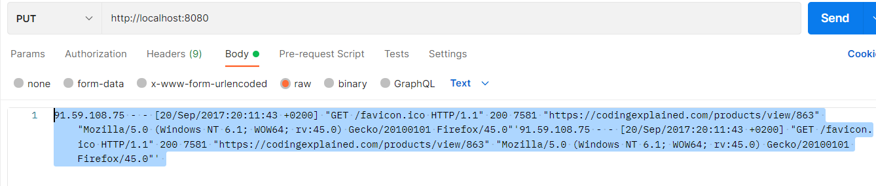

curl --location --request PUT 'http://localhost:8080' \

--header 'Content-Type: text/plain' \

--data-raw '91.59.108.75 - - [20/Sep/2017:20:11:43 +0200] "GET /favicon.ico HTTP/1.1" 200 7581 "https://codingexplained.com/products/view/863" "Mozilla/5.0 (Windows NT 6.1; WOW64; rv:45.0) Gecko/20100101 Firefox/45.0"'\''91.59.108.75 - - [20/Sep/2017:20:11:43 +0200] "GET /favicon.ico HTTP/1.1" 200 7581 "https://codingexplained.com/products/view/863" "Mozilla/5.0 (Windows NT 6.1; WOW64; rv:45.0) Gecko/20100101 Firefox/45.0"'\'' '

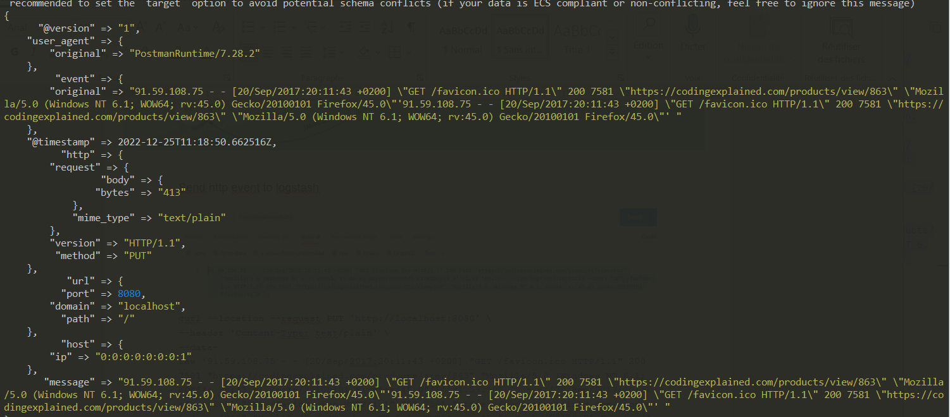

**Parsing requests with Grok**

Model of patterns used in Grok plugin

<https://github.com/logstash-plugins/logstash-patterns-core/tree/main/patterns/ecs-v1>

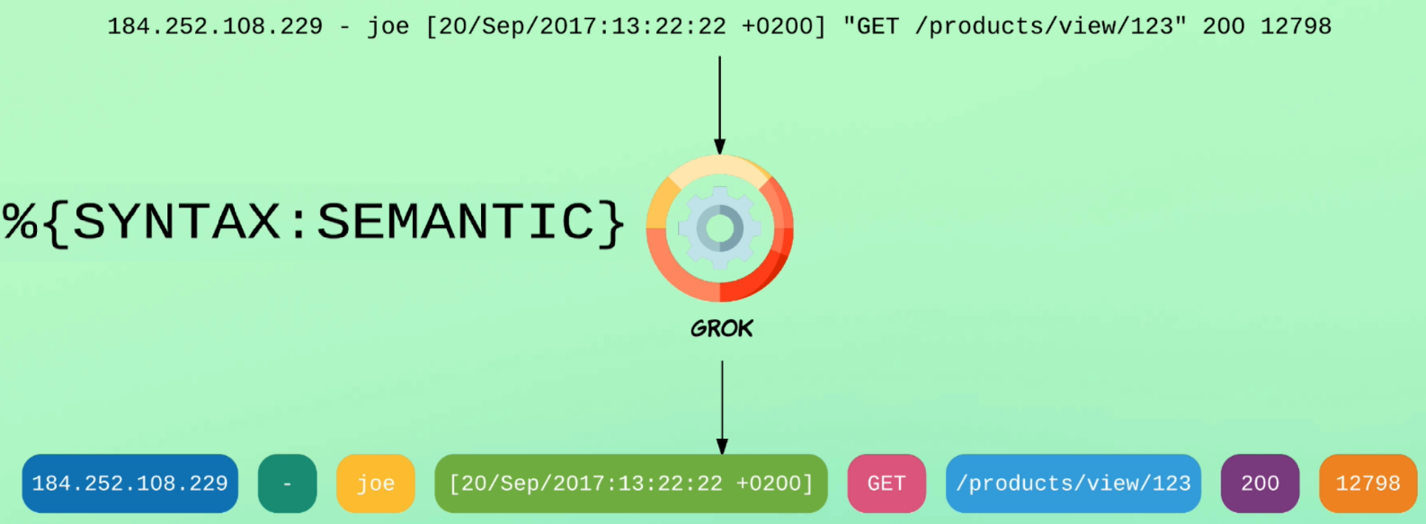<https://github.com/logstash-plugins/logstash-patterns-core/blob/main/patterns/ecs-v1/grok-patterns>

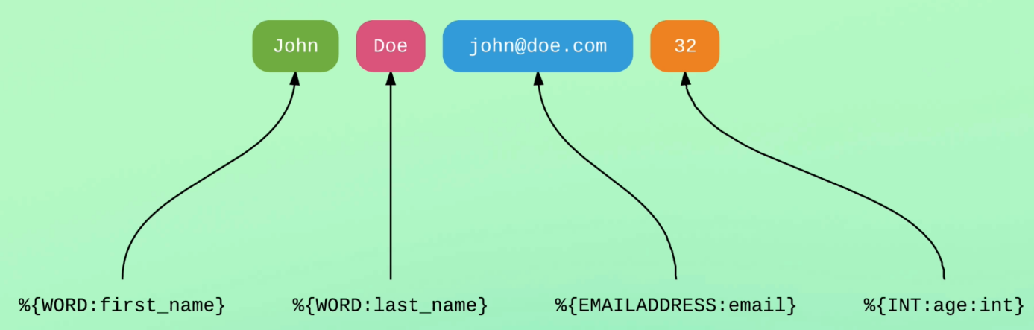

input {

    file {

        path => " C:/Devs-and-tools/install/ELK/logstash-8.2.3/data/event-data/apache_access.log"

        start_position => "beginning"

    }

    http {

    }

}

filter {

    grok {

        match => {

             "message" => "%{IP:ip_address} %{USER:identity} %{USER:auth} \[%{HTTPDATE:req_ts}\] \"%{WORD:http_verb} %{URIPATHPARAM:req_path} HTTP/%{NUMBER:http_version}\" %{INT:http_status:int} %{INT:num_bytes:int}"

             }

    }

}

output {

    stdout {

        codec => rubydebug

    }

}

Format message log with the filter

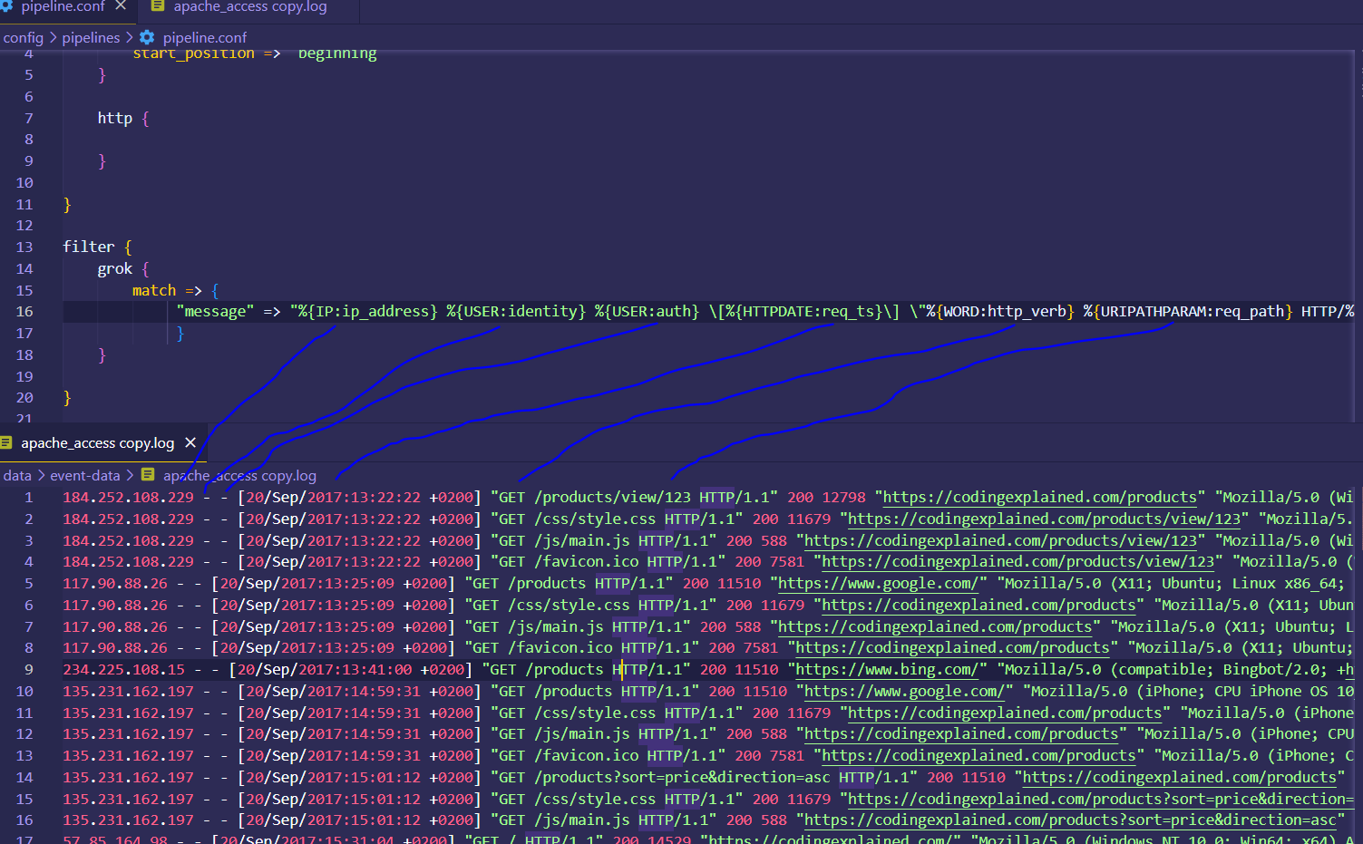



{

"num_bytes" => 7581,

"event" => {

"original" => "91.59.108.75 - - [20/Sep/2017:20:11:43 +0200] \"GET /favicon.ico HTTP/1.1\" 200 7581 \"https://codingexplained.com/products/view/863\" \"Mozilla/5.0 (Windows NT 6.1; WOW64; rv:45.0) Gecko/20100101 Firefox/45.0\"'91.59.108.75 - - [20/Sep/2017:20:11:43 +0200] \"GET /favicon.ico HTTP/1.1\" 200 7581 \"https://codingexplained.com/products/view/863\" \"Mozilla/5.0 (Windows NT 6.1; WOW64; rv:45.0) Gecko/20100101 Firefox/45.0\"' "

},

"url" => {

"domain" => "localhost",

"port" => 8080,

"path" => "/"

},

"http_verb" => "GET",

"host" => {

"ip" => "0:0:0:0:0:0:0:1"

},

"req_path" => "/favicon.ico",

"req_ts" => "20/Sep/2017:20:11:43 +0200",

"@version" => "1",

"auth" => "-",

"http_version" => "1.1",

"@timestamp" => 2022-12-25T12:19:57.614474300Z,

"http" => {

"version" => "HTTP/1.1",

"request" => {

"body" => {

"bytes" => "413"

},

"mime_type" => "text/plain"

},

"method" => "PUT"

},

"user_agent" => {

"original" => "PostmanRuntime/7.28.2"

},

"ip_address" => "91.59.108.75",

"identity" => "-",

"http_status" => 200,

"message" => "91.59.108.75 - - [20/Sep/2017:20:11:43 +0200] \"GET /favicon.ico HTTP/1.1\" 200 7581 \"https://codingexplained.com/products/view/863\" \"Mozilla/5.0 (Windows NT 6.1; WOW64; rv:45.0) Gecko/20100101 Firefox/45.0\"'91.59.108.75 - - [20/Sep/2017:20:11:43 +0200] \"GET /favicon.ico HTTP/1.1\" 200 7581 \"https://codingexplained.com/products/view/863\" \"Mozilla/5.0 (Windows NT 6.1; WOW64; rv:45.0) Gecko/20100101 Firefox/45.0\"' "

}

Using template httpd

<https://github.com/logstash-plugins/logstash-patterns-core/blob/main/patterns/ecs-v1/httpd>

HTTPD_COMBINEDLOG

input {

    file {

        path => "C:Devs-and-tools\install\ELK\logstash-8.2.3\data\event-data\apache_access.log "

        start_position => "beginning"

    }

    http {  }

}

filter {

    grok {

        match => { "message" => '%{HTTPD_COMMONLOG} "%{GREEDYDATA:referrer}" "%{GREEDYDATA:agent}"' }

    }

    mutate {

        convert => {

            "response" => "integer"

            "bytes" => "integer"

        }

    }

}

output {

    stdout {

        codec => rubydebug

    }

}

Accessing field values

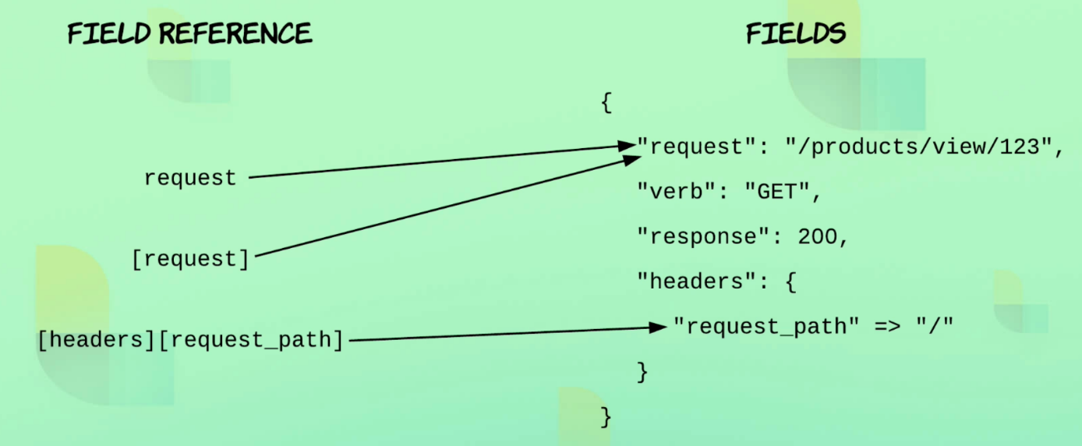

input {

    file {

        path => "C:/Devs-and-tools/install/ELK/logstash-8.2.3/data/event-data/apache_*.log"

        start_position => "beginning"

        type => "access"

    }

    http {

        type => "access"

    }

}

filter {

    grok {

        match => { "message" => '%{HTTPD_COMMONLOG} "%{GREEDYDATA:referrer}" "%{GREEDYDATA:agent}"' }

    }

    mutate {

        convert => {

            "response" => "integer"

            "bytes" => "integer"

        }

    }

}

output {

    stdout {

        codec => rubydebug

    }

    file {

        path => "%{type}.log"

    }

}

{

"agent" => "Mozilla/5.0 (Windows NT 6.1; WOW64; rv:45.0) Gecko/20100101 Firefox/45.0",

"event" => {

"original" => "91.59.108.75 - - [20/Sep/2017:20:11:43 +0200] \"GET /favicon.ico HTTP/1.1\" 200 7581 \"https://codingexplained.com/products/view/863\" \"Mozilla/5.0 (Windows NT 6.1; WOW64; rv:45.0) Gecko/20100101 Firefox/45.0\"'91.59.108.75 - - [20/Sep/2017:20:11:43 +0200] \"GET /favicon.ico HTTP/1.1\" 200 7581 \"https://codingexplained.com/products/view/863\" \"Mozilla/5.0 (Windows NT 6.1; WOW64; rv:45.0) Gecko/20100101 Firefox/45.0\"' "

},

"url" => {

"domain" => "localhost",

"port" => 8080,

"path" => "/",

"original" => "/favicon.ico"

},

"host" => {

"ip" => "0:0:0:0:0:0:0:1"

},

"type" => "access",

"@version" => "1",

"@timestamp" => 2022-12-25T13:00:18.879113500Z,

"http" => {

"version" => [

[0] "HTTP/1.1",

[1] "1.1"

],

"request" => {

"body" => {

"bytes" => "413"

},

"mime_type" => "text/plain",

"method" => "GET"

},

"method" => "PUT",

"response" => {

"status_code" => 200,

"body" => {

"bytes" => 7581

}

}

},

"user_agent" => {

"original" => "PostmanRuntime/7.28.2"

},

"timestamp" => "20/Sep/2017:20:11:43 +0200",

"source" => {

"address" => "91.59.108.75"

},

"referrer" => "https://codingexplained.com/products/view/863\" \"Mozilla/5.0 (Windows NT 6.1; WOW64; rv:45.0) Gecko/20100101 Firefox/45.0\"'91.59.108.75 - - [20/Sep/2017:20:11:43 +0200] \"GET /favicon.ico HTTP/1.1\" 200 7581 \"https://codingexplained.com/products/view/863",

"message" => "91.59.108.75 - - [20/Sep/2017:20:11:43 +0200] \"GET /favicon.ico HTTP/1.1\" 200 7581 \"https://codingexplained.com/products/view/863\" \"Mozilla/5.0 (Windows NT 6.1; WOW64; rv:45.0) Gecko/20100101 Firefox/45.0\"'91.59.108.75 - - [20/Sep/2017:20:11:43 +0200] \"GET /favicon.ico HTTP/1.1\" 200 7581 \"https://codingexplained.com/products/view/863\" \"Mozilla/5.0 (Windows NT 6.1; WOW64; rv:45.0) Gecko/20100101 Firefox/45.0\"' "

}

[2022-12-25T14:00:19,124][INFO ][logstash.outputs.file ][main][39bb55265494f830d1a4ba4871030ab8dd2888940d111775e981a1dcdfbcb523] Opening file {:path=>"C:/Devs-and-tools/install/ELK/logstash-8.2.3/access.log"}

[2022-12-25T14:00:35,450][INFO ][logstash.outputs.file ][main][39bb55265494f830d1a4ba4871030ab8dd2888940d111775e981a1dcdfbcb523] Closing file C:/Devs-and-tools/install/ELK/logstash-8.2.3/access.log

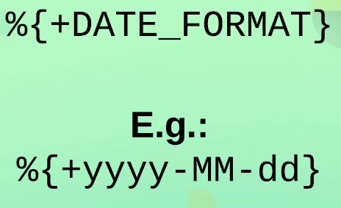**Formatting Date**

input {

    file {

        path => "C:/Devs-and-tools/install/ELK/logstash-8.2.3/data/event-data/apache_*.log"

        start_position => "beginning"

        type => "access"

    }

    http {

        type => "access"

    }

}

filter {

    grok {

        match => { "message" => '%{HTTPD_COMMONLOG} "%{GREEDYDATA:referrer}" "%{GREEDYDATA:agent}"' }

    }

    mutate {

        convert => {

            "response" => "integer"

            "bytes" => "integer"

        }

    }

}

output {

    stdout {

        codec => rubydebug

    }

    file {

        path => "%{type}_%{+yyyy_MM_dd}.log"

    }

}

C:/Devs-and-tools/install/ELK/logstash-8.2.3/access_2022_12_25.log

**Setting Time of the Event**

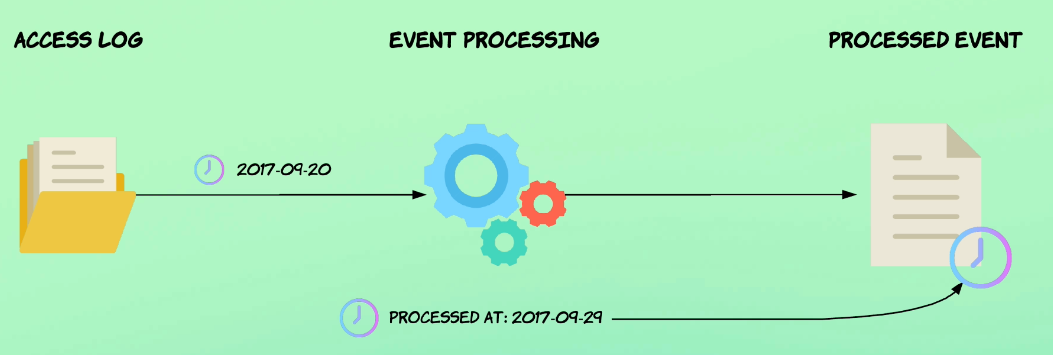

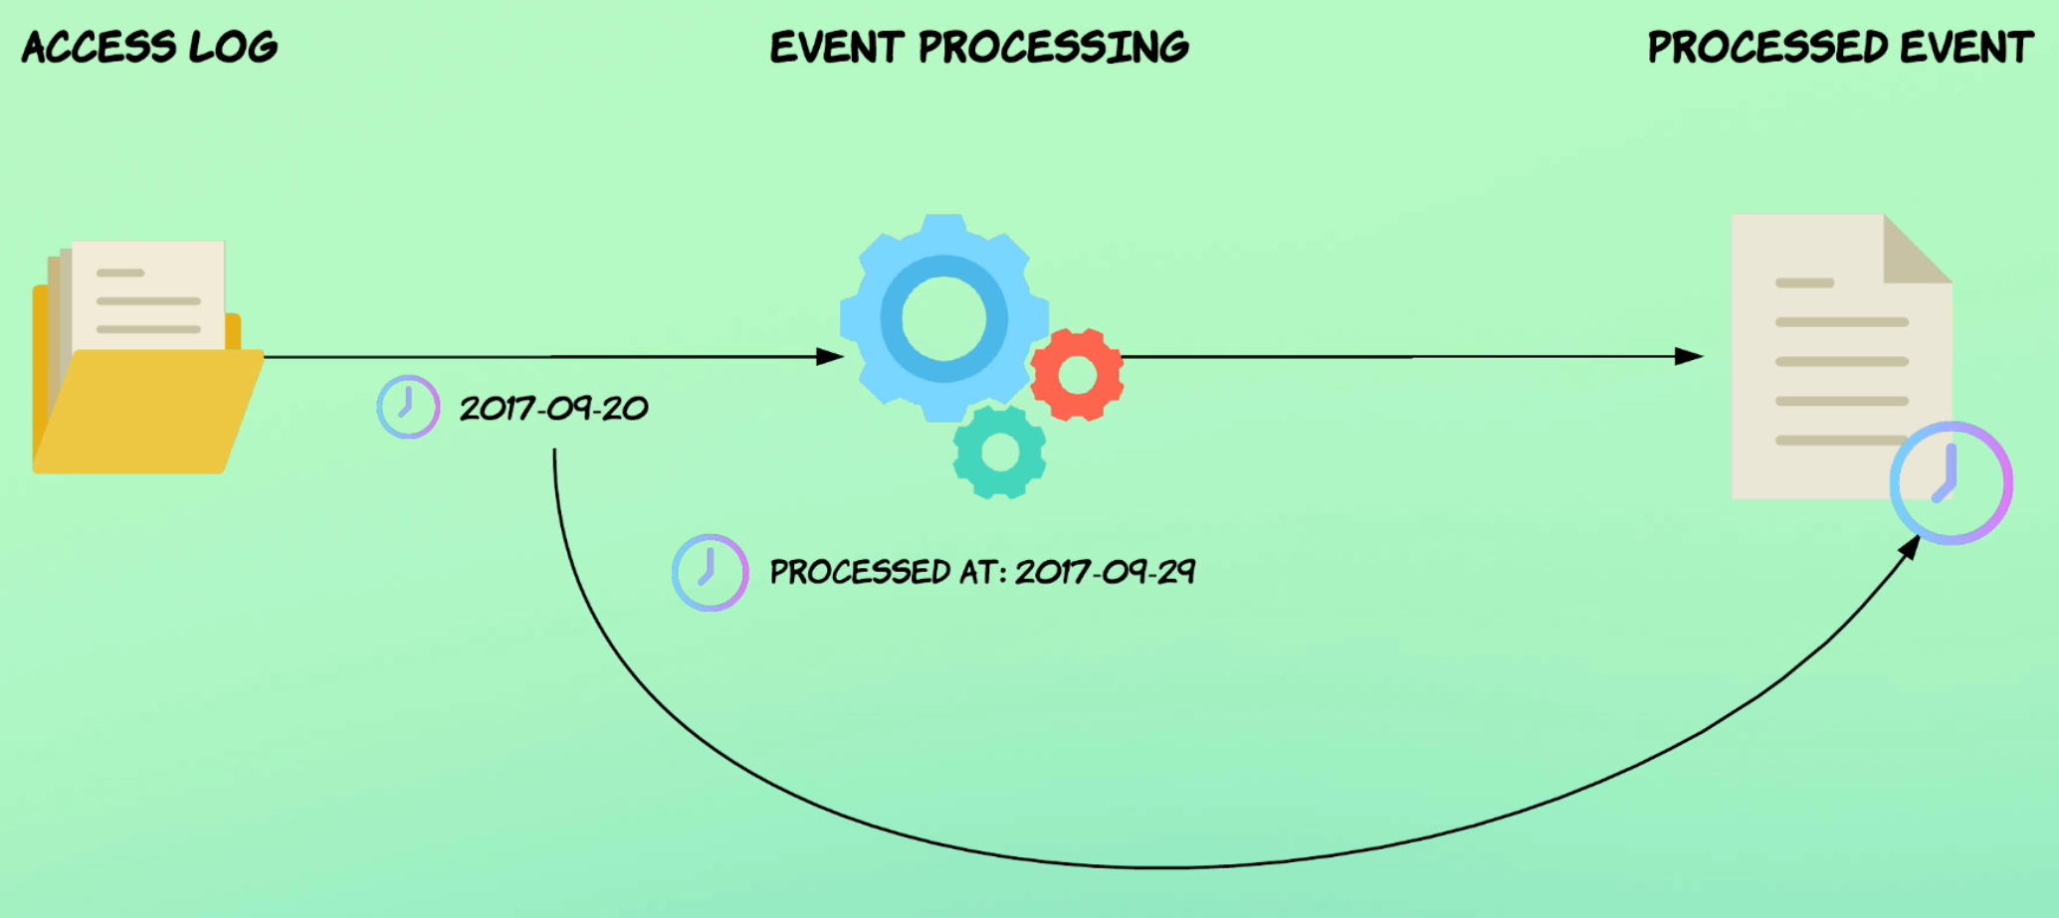

input {

    file {

        path => "C:/Devs-and-tools/install/ELK/logstash-8.2.3/data/event-data/apache_*.log"

        start_position => "beginning"

        type => "access"

    }

    http {

        type => "access"

    }

}

filter {

    grok {

        match => { "message" => '%{HTTPD_COMMONLOG} "%{GREEDYDATA:referrer}" "%{GREEDYDATA:agent}"' }

    }

    mutate {

        convert => {

            "response" => "integer"

            "bytes" => "integer"

        }

    }

    date {

        match => ["timestamp" , "dd/MMM/yyyy:HH:mm:ss Z"]

        remove_field => ["timestamp"]

    }

}

output {

    stdout {

        codec => rubydebug

    }

    file {

        path => "%{type}_%{+yyyy_MM_dd}.log"

    }

}

**Introduction to conditional statements**

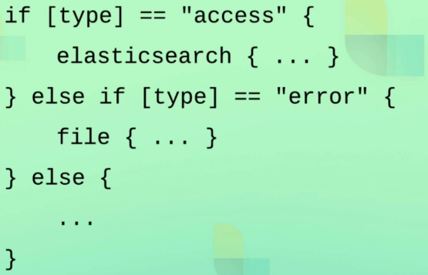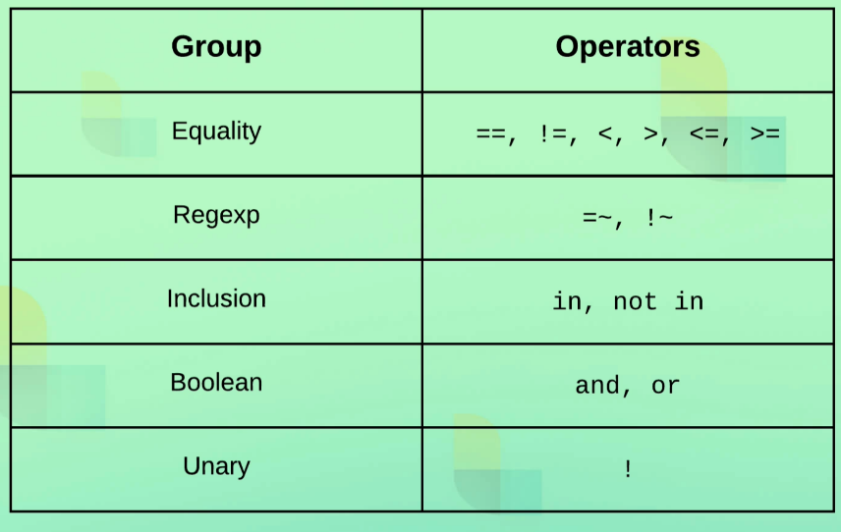

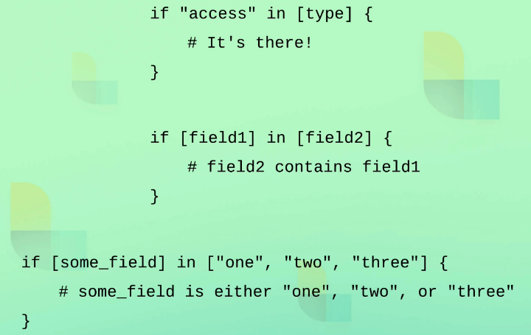

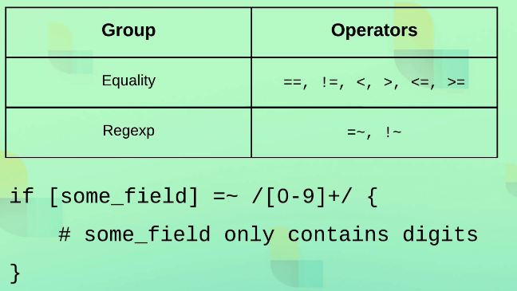

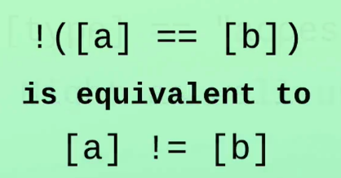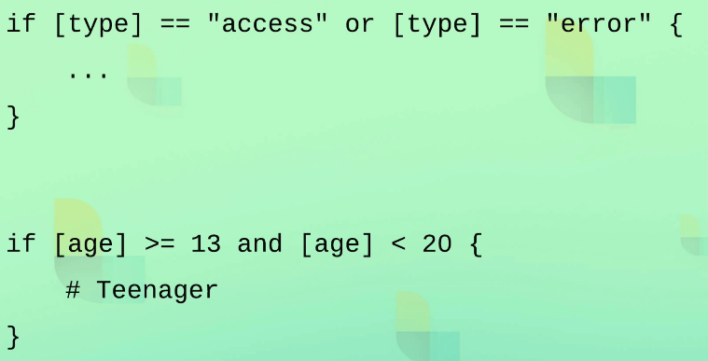

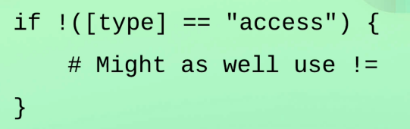

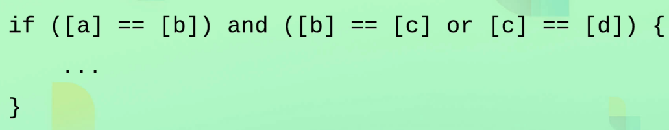

input {

    file {

        path => "C:/Devs-and-tools/install/ELK/logstash-8.2.3/data/event-data/apache_*.log"

        start_position => "beginning"

    }

    http {

    }

}

filter {

    if [headers][request_path] =~ "error" or [path] =~ "errors" {

        mutate {

            replace => { type => "error"}

        }

    } else {

        mutate {

            replace => { type => "access"}

        }

        grok {

            match => { "message" => '%{HTTPD_COMMONLOG} "%{GREEDYDATA:referrer}" "%{GREEDYDATA:agent}"' }

        }

        if "_grokparcefailure" in [tags] {

            drop { }

        }

        mutate {

            convert => {

                "response" => "integer"

                "bytes" => "integer"

            }

        }

        date {

            match => ["timestamp" , "dd/MMM/yyyy:HH:mm:ss Z"]

            remove_field => ["timestamp"]

        }

    }

}

output {

    stdout {

        codec => rubydebug

    }

    file {

        path => "%{type}_%{+yyyy_MM_dd}.log"

    }

}

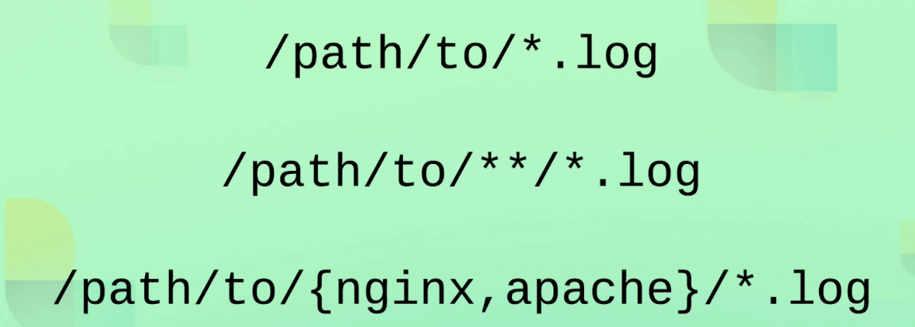

curl --location --request PUT 'http://localhost:8080/**error'** \

--header 'Content-Type: text/plain' \

--data-raw '91.59.108.75 - - [20/Sep/2017:20:11:43 +0200] "GET /favicon.ico HTTP/1.1" 200 7581 "https://codingexplained.com/products/view/863" "Mozilla/5.0 (Windows NT 6.1; WOW64; rv:45.0) Gecko/20100101 Firefox/45.0"'\''91.59.108.75 - - [20/Sep/2017:20:11:43 +0200] "GET /favicon.ico HTTP/1.1" 200 7581 "https://codingexplained.com/products/view/863" "Mozilla/5.0 (Windows NT 6.1; WOW64; rv:45.0) Gecko/20100101 Firefox/45.0"'\'' '

{

"agent" => "Mozilla/5.0 (Windows NT 6.1; WOW64; rv:45.0) Gecko/20100101 Firefox/45.0",

"event" => {

"original" => "91.59.108.75 - - [20/Sep/2017:20:11:43 +0200] \"GET /favicon.ico HTTP/1.1\" 200 7581 \"https://codingexplained.com/products/view/863\" \"Mozilla/5.0 (Windows NT 6.1; WOW64; rv:45.0) Gecko/20100101 Firefox/45.0\"'91.59.108.75 - - [20/Sep/2017:20:11:43 +0200] \"GET /favicon.ico HTTP/1.1\" 200 7581 \"https://codingexplained.com/products/view/863\" \"Mozilla/5.0 (Windows NT 6.1; WOW64; rv:45.0) Gecko/20100101 Firefox/45.0\"' "

},

"url" => {

"domain" => "localhost",

"port" => 8080,

"path" => "/",

"original" => "/favicon.ico"

},

"host" => {

"ip" => "0:0:0:0:0:0:0:1"

},

"type" => "error",

"@version" => "1",

"@timestamp" => 2017-09-20T18:11:43Z,

"http" => {

"version" => [

[0] "HTTP/1.1",

[1] "1.1"

],

"request" => {

"body" => {

"bytes" => "413"

},

"mime_type" => "text/plain",

"method" => "GET"

},

"method" => "PUT",

"response" => {

"status_code" => 200,

"body" => {

"bytes" => 7581

}

}

},

"user_agent" => {

"original" => "PostmanRuntime/7.28.2"

},

"source" => {

"address" => "91.59.108.75"

},

"referrer" => "https://codingexplained.com/products/view/863\" \"Mozilla/5.0 (Windows NT 6.1; WOW64; rv:45.0) Gecko/20100101 Firefox/45.0\"'91.59.108.75 - - [20/Sep/2017:20:11:43 +0200] \"GET /favicon.ico HTTP/1.1\" 200 7581 \"https://codingexplained.com/products/view/863",

"message" => "91.59.108.75 - - [20/Sep/2017:20:11:43 +0200] \"GET /favicon.ico HTTP/1.1\" 200 7581 \"https://codingexplained.com/products/view/863\" \"Mozilla/5.0 (Windows NT 6.1; WOW64; rv:45.0) Gecko/20100101 Firefox/45.0\"'91.59.108.75 - - [20/Sep/2017:20:11:43 +0200] \"GET /favicon.ico HTTP/1.1\" 200 7581 \"https://codingexplained.com/products/view/863\" \"Mozilla/5.0 (Windows NT 6.1; WOW64; rv:45.0) Gecko/20100101 Firefox/45.0\"' "

}

**Geographical data enrichment**

input {

    file {

        path => "C:/Devs-and-tools/install/ELK/logstash-8.2.3/data/event-data/apache_*.log"

        start_position => "beginning"

    }

    http {

    }

}

filter {

    if [headers][request_path] =~ "error" or [path] =~ "errors" {

        mutate {

            replace => { type => "error" }

        }

    } else {

        mutate {

            replace => { type => "access" }

        }

        grok {

            match => { "message" => '%{HTTPD_COMMONLOG} "%{GREEDYDATA:referrer}" "%{GREEDYDATA:agent}"' }

        }

        if "_grokparsefailure" in [tags] {

            drop { }

        }

        mutate {

            convert => {

                "response" => "integer"

                "bytes" => "integer"

            }

        }

        date {

            match => [ "timestamp", "dd/MMM/yyyy:HH:mm:ss Z" ]

            remove_field => [ "timestamp" ]

        }

        geoip {

            source => "clientip"

        }

    }

}

output {

    stdout {

        codec => rubydebug

    }

    file {

        path => "%{type}_%{+yyyy_MM_dd}.log"

    }

}

**Parsing user agents**

input {

    file {

        path => "C:/Devs-and-tools/install/ELK/logstash-8.2.3/data/event-data/apache_*.log"

        start_position => "beginning"

    }

    http {

    }

}

filter {

    if [headers][request_path] =~ "error" or [path] =~ "errors" {

        mutate {

            replace => { type => "error" }

        }

    } else {

        mutate {

            replace => { type => "access" }

        }

        grok {

            match => { "message" => '%{HTTPD_COMMONLOG} "%{GREEDYDATA:referrer}" "%{GREEDYDATA:agent}"' }

        }

        useragent {

            source => "agent"

            target => "ua"

        }

        if "_grokparsefailure" in [tags] {

            drop { }

        }

        mutate {

            convert => {

                "response" => "integer"

                "bytes" => "integer"

            }

        }

        date {

            match => [ "timestamp", "dd/MMM/yyyy:HH:mm:ss Z" ]

            remove_field => [ "timestamp" ]

        }

    }

}

output {

    stdout {

        codec => rubydebug

    }

    file {

        path => "%{type}_%{+yyyy_MM_dd}.log"

    }

}

useragent {

            source => "agent" = web browser

            target => "ua" = object create in the output

        }

Response

{

"@timestamp" => 2017-09-20T18:11:43Z,

"type" => "access",

"agent" => "Mozilla/5.0 (Windows NT 6.1; WOW64; rv:45.0) Gecko/20100101 Firefox/45.0",

"ua" => {

"os" => {

"name" => "Windows",

"version" => "7",

"full" => "Windows 7"

},

"name" => "Firefox",

"version" => "45.0",

"device" => {

"name" => "Other"

}

},

"user_agent" => {

"original" => "PostmanRuntime/7.28.2"

},

"url" => {

"port" => 8080,

"path" => "/",

"original" => "/favicon.ico",

"domain" => "localhost"

},

"host" => {

"ip" => "0:0:0:0:0:0:0:1"

},

input {

    file {

        path => "C:/Devs-and-tools/install/ELK/logstash-8.2.3/data/event-data/apache_*.log"

        start_position => "beginning"

    }

    http {

    }

}

filter {

    if [headers][request_path] =~ "error" or [path] =~ "errors" {

        mutate {

            replace => { type => "error" }

        }

    } else {

        mutate {

            replace => { type => "access" }

        }

        grok {

            match => { "message" => '%{HTTPD_COMMONLOG} "%{GREEDYDATA:referrer}" "%{GREEDYDATA:agent}"' }

        }

        if "_grokparsefailure" in [tags] {

            drop { }

        }

        useragent {

            source => "agent"

            target => "ua"

        }

*# Admin pages*

        if [request] =~ /^\/admin\// {

            drop { }

        }

*# Static files*

        if [request] =~ /^\/js\//

            or [request] =~ /^\/css\//

            or [request] in ["/robots.txt", "/favicon.ico"] {

            drop { }

        }

*# Crawlers*

        if [ua][device] == "Spider" {

            drop { }

        }

        mutate {

            convert => {

                "response" => "integer"

                "bytes" => "integer"

            }

        }

        date {

            match => [ "timestamp", "dd/MMM/yyyy:HH:mm:ss Z" ]

            remove_field => [ "timestamp" ]

        }

*# geoip {*

*#   source => "clientip"*

*# }*

    }

    mutate {

        remove_field => [ "headers", "@version", "host" ]

    }

}

output {

    stdout {

        codec => rubydebug

    }

    file {

        path => "%{type}_%{+yyyy_MM_dd}.log"

    }

}

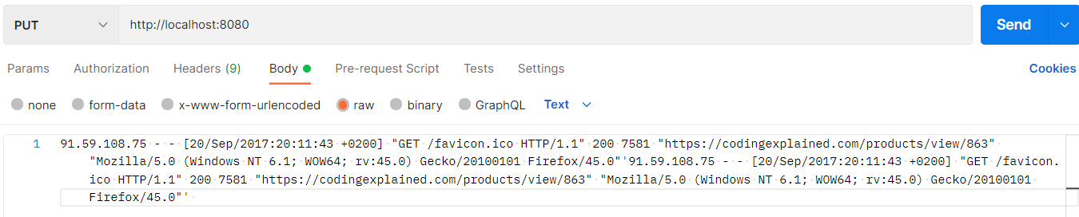

**Sending processed events to Elasticsearch**

Elasticsearch

Edit elasticsearch.yml to disable security

# vi elasticsearch-8.2.2\config\elasticsearch.yml

xpack.security.enabled: false

xpack.security.enrollment.enabled: false

*# Enable encryption for HTTP API client connections, such as Kibana, Logstash, and Agents*

xpack.security.http.ssl:

  enabled: false

  keystore.path: certs/http.p12

*# Enable encryption and mutual authentication between cluster nodes*

xpack.security.transport.ssl:

  enabled: false

  verification_mode: certificate

  keystore.path: certs/transport.p12

  truststore.path: certs/transport.p12

Run Elasticsearch

# elasticsearch-8.2.2\bin\elasticsearch.sh or elasticsearch.bat

Add config

# logstash-8.2.3\config\pipelines\pipeline.conf

input {

    file {

        path => "C:/Devs-and-tools/install/ELK/logstash-8.2.3/data/event-data/apache_*.log"

        start_position => "beginning"

    }

    file {

        path => " C:/Devs-and-tools/install/ELK/logstash-8.2.3/data/event-data/java_erros*.log"

        start_position => "beginning"

        codec => multiline {

            pattern => "^(\s+|\t)|(Caused by:)"

            what => "previous"

            auto_flush_interval => 5

        }

    }

}

filter {

    if [headers][request_path] =~ "error" or [path] =~ "errors" {

        mutate {

            replace => { type => "error" }

        }

    } else {

        mutate {

            replace => { type => "access" }

        }

        grok {

            match => { "message" => '%{HTTPD_COMMONLOG} "%{GREEDYDATA:referrer}" "%{GREEDYDATA:agent}"' }

        }

        if "_grokparsefailure" in [tags] {

            drop { }

        }

        useragent {

            source => "agent"

            target => "ua"

        }

*# Admin pages*

        if [request] =~ /^\/admin\// {

            drop { }

        }

*# Static files*

        if [request] =~ /^\/js\//

            or [request] =~ /^\/css\//

            or [request] in ["/robots.txt", "/favicon.ico"] {

            drop { }

        }

*# Crawlers*

        if [ua][device] == "Spider" {

            drop { }

        }

        mutate {

            convert => {

                "response" => "integer"

                "bytes" => "integer"

            }

        }

        date {

            match => [ "timestamp", "dd/MMM/yyyy:HH:mm:ss Z" ]

            remove_field => [ "timestamp" ]

        }

*# geoip {*

*#   source => "clientip"*

*# }*

    }

    mutate {

        remove_field => [ "headers", "@version", "host" ]

    }

}

output {

    if [type] == "access" {

        elasticsearch {

            hosts => ["localhost:9200"]

            document_type => "default"

*#index => "%{type}-%{+YYYY.MM.dd}"*

            http_compression => true

        }

    } else {

        stdout {

            codec => rubydebug

        }

    }

}

# bin\logstash -f config/pipelines/pipeline.conf --config.reload.automatic

[2022-12-25T23:00:40,640][INFO ][o.e.c.m.MetadataIndexTemplateService] [PAR-N-PW10-5273] adding index template [ecs-logstash] for index patterns [ecs-logstash-*]

[2022-12-25T23:00:42,020][INFO ][o.e.c.m.MetadataCreateIndexService] [PAR-N-PW10-5273] [ecs-logstash-2022.12.25-000001] creating index, cause [api], templates [ecs-logstash], shards [1]/[1]

[2022-12-25T23:00:42,717][INFO ][o.e.x.i.a.TransportPutLifecycleAction] [PAR-N-PW10-5273] adding index lifecycle policy [logstash-policy]

[2022-12-25T23:00:42,824][INFO ][o.e.x.i.IndexLifecycleTransition] [PAR-N-PW10-5273] moving index [ecs-logstash-2022.12.25-000001] from [null] to [{"phase":"new","action":"complete","name":"complete"}] in policy [logstash-policy]

[2022-12-25T23:00:42,938][INFO ][o.e.x.i.IndexLifecycleTransition] [PAR-N-PW10-5273] moving index [ecs-logstash-2022.12.25-000001] from [{"phase":"new","action":"complete","name":"complete"}] to [{"phase":"hot","action":"unfollow","name":"branch-check-unfollow-prerequisites"}] in policy [logstash-policy]

**Handling Multiline events, the easy way**

Remove sincedb file before starting logstash

# rm /data/plugins/inputs/file/.sincedb_*

input {

    file {

        path => "C:/Devs-and-tools/install/ELK/logstash-8.2.3/data/event-data/apache_*.log"

        start_position => "beginning"

    }

    file {

        path => "C:/Devs-and-tools/install/ELK/logstash-8.2.3/data/event-data/java_errors.log"

        start_position => "beginning"

        codec => multiline {

            pattern => "^%{CATALINA_DATESTAMP}"

            negate => true

            what => "previous"

            auto_flush_interval => 5

        }

    }

}

filter {

    if [headers][request_path] =~ "error" or [path] =~ "errors" {

        mutate {

            replace => { type => "error" }

        }

    } else {

        mutate {

            replace => { type => "access" }

        }

        grok {

            match => { "message" => '%{HTTPD_COMMONLOG} "%{GREEDYDATA:referrer}" "%{GREEDYDATA:agent}"' }

        }

        if "_grokparsefailure" in [tags] {

            drop { }

        }

        useragent {

            source => "agent"

            target => "ua"

        }

*# Admin pages*

        if [request] =~ /^\/admin\// {

            drop { }

        }

*# Static files*

        if [request] =~ /^\/js\//

            or [request] =~ /^\/css\//

            or [request] in ["/robots.txt", "/favicon.ico"] {

            drop { }

        }

*# Crawlers*

        if [ua][device] == "Spider" {

            drop { }

        }

        mutate {

            convert => {

                "response" => "integer"

                "bytes" => "integer"

            }

        }

        date {

            match => [ "timestamp", "dd/MMM/yyyy:HH:mm:ss Z" ]

            remove_field => [ "timestamp" ]

        }

*# geoip {*

*#   source => "clientip"*

*# }*

    }

    mutate {

        remove_field => [ "headers", "@version", "host" ]

    }

}

output {

    if [type] == "access" {

        elasticsearch {

            hosts => ["localhost:9200"]

            document_type => "default"

*#index => "%{type}-%{+YYYY.MM.dd}"*

            http_compression => true

        }

    } else {

        stdout {

            codec => rubydebug

        }

    }

}

Add log in java_error.log

**Parsing Stack trace with Grock**

Add filter grok

**(?<field_name>regex_pattern)**

input {

    file {

        path => "C:/Devs-and-tools/install/ELK/logstash-8.2.3/data/event-data/apache_*.log"

        start_position => "beginning"

    }

    file {

        path => "C:/Devs-and-tools/install/ELK/logstash-8.2.3/data/event-data/java_errors.log"

        start_position => "beginning"

        codec => multiline {

            pattern => "^%{CATALINA_DATESTAMP}"

            negate => true

            what => "previous"

            auto_flush_interval => 5

        }

    }

}

filter {

    if [headers][request_path] =~ "error" or [path] =~ "errors" {

        mutate {

            replace => { type => "error" }

        }

        grok {

            match => { "message" => "%{CATALINA_DATESTAMP:timestamp} %{LOGLEVEL:level} %{JAVACLASS:class}: (?<msg>.+?(?=(\r\n|\r|\n)))" }

        }

    } else {

        mutate {

            replace => { type => "access" }

        }

        grok {

            match => { "message" => '%{HTTPD_COMMONLOG} "%{GREEDYDATA:referrer}" "%{GREEDYDATA:agent}"' }

        }

        if "_grokparsefailure" in [tags] {

            drop { }

        }

        useragent {

            source => "agent"

            target => "ua"

        }

*# Admin pages*

        if [request] =~ /^\/admin\// {

            drop { }

        }

*# Static files*

        if [request] =~ /^\/js\//

            or [request] =~ /^\/css\//

            or [request] in ["/robots.txt", "/favicon.ico"] {

            drop { }

        }

*# Crawlers*

        if [ua][device] == "Spider" {

            drop { }

        }

        mutate {

            convert => {

                "response" => "integer"

                "bytes" => "integer"

            }

        }

        date {

            match => [ "timestamp", "dd/MMM/yyyy:HH:mm:ss Z" ]

            remove_field => [ "timestamp" ]

        }

*#geoip {*

*#   source => "clientip"*

*#}*

    }

    mutate {

        remove_field => [ "headers", "@version", "host" ]

    }

}

output {

    if [type] == "access" {

*#elasticsearch {*

*#   hosts => ["localhost:9200"] # load balances between the hosts*

*#   document_type => "default" # Defaults to "type" field*

*#index => "%{type}-%{+YYYY.MM.dd}" # Defaults to: logstash-%{+YYYY.MM.dd}*

*#   http_compression => true*

*#}*

    } else {

        stdout {

            codec => rubydebug {

                metadata => true

            }

        }

    }

}

Remove all file

# rm /data/plugins/inputs/file/.sincedb_*

**Working with @metadata**

input {

    file {

        path => "C:/Devs-and-tools/install/ELK/logstash-8.2.3/data/event-data/apache_*.log"

        start_position => "beginning"

    }

    file {

        path => "C:/Devs-and-tools/install/ELK/logstash-8.2.3/data/event-data/java_errors.log"

        start_position => "beginning"

        codec => multiline {

            pattern => "^%{CATALINA_DATESTAMP}"

            negate => true

            what => "previous"

            auto_flush_interval => 5

        }

    }

}

filter {

    if [headers][request_path] =~ "error" or [path] =~ "errors" {

        mutate {

            replace => { type => "error" }

        }

        grok {

            match => { "message" => "%{CATALINA_DATESTAMP:[@metadata][timestamp]} %{LOGLEVEL:level} %{JAVACLASS:class}: (?<msg>.+?(?=(\r\n|\r|\n)))" }

        }

        date {

            match => [ "[@metadata][timestamp]", "MMM dd, yyyy HH:mm:ss a" ]

        }

    } else {

        mutate {

            replace => { type => "access" }

        }

        grok {

            match => { "message" => '%{HTTPD_COMMONLOG} "%{GREEDYDATA:referrer}" "%{GREEDYDATA:agent}"' }

        }

        if "_grokparsefailure" in [tags] {

            drop { }

        }

        useragent {

            source => "agent"

            target => "ua"

        }

*# Admin pages*

        if [request] =~ /^\/admin\// {

            drop { }

        }

*# Static files*

        if [request] =~ /^\/js\//

            or [request] =~ /^\/css\//

            or [request] in ["/robots.txt", "/favicon.ico"] {

            drop { }

        }

*# Crawlers*

        if [ua][device] == "Spider" {

            drop { }

        }

        mutate {

            convert => {

                "response" => "integer"

                "bytes" => "integer"

            }

        }

        date {

            match => [ "timestamp" , "dd/MMM/yyyy:HH:mm:ss Z" ]

            remove_field => [ "timestamp" ]

        }

*#geoip {*

*#   source => "clientip"*

*#}*

    }

    mutate {

        remove_field => [ "headers", "@version", "host" ]

    }

}

output {

    if [type] == "access" {

*#elasticsearch {*

*#hosts => ["localhost:9200"] # load balances between the hosts*

*#document_type => "default" # Defaults to "type" field*

*#index => "%{type}-%{+YYYY.MM.dd}" # Defaults to: logstash-%{+YYYY.MM.dd}*

*#http_compression => true*

*#}*

    } else {

        stdout {

            codec => rubydebug {

                metadata => true

            }

        }

    }

}

Remove all file

# rm /data/plugins/inputs/file/.sincedb_*

Restart logstash

# bin\logstash -f config/pipelines/pipeline.conf --config.reload.automatic

**Running multiple pipelines**

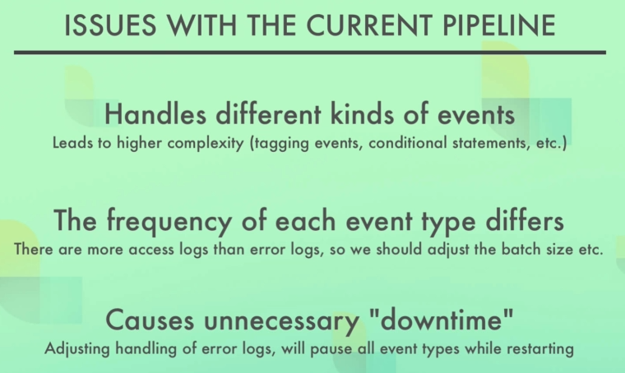

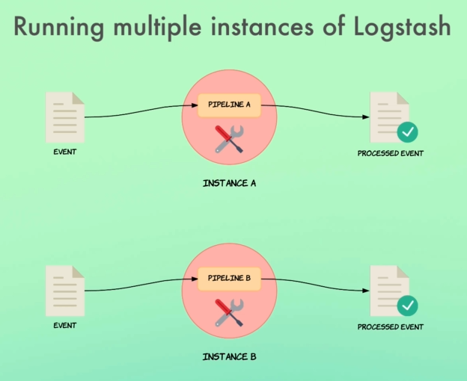

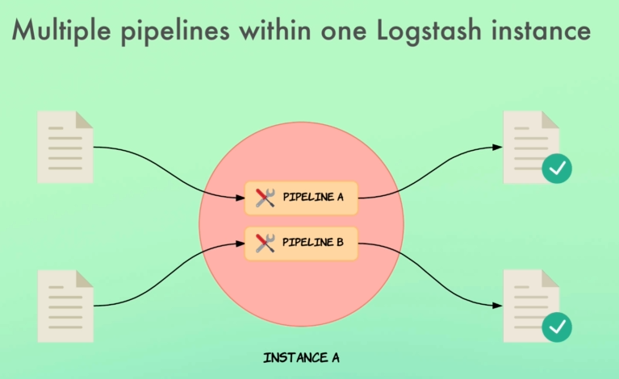

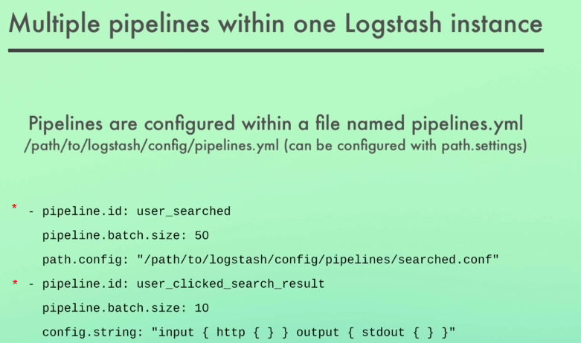

Start multiple pipelines

Without specifying the path of files

# bin\logstash --config.reload.automatic

# rm .sincedb_* to make log to start from beginning we remove file

Add configuration in logstash/config/pipelines.yml

*#   path.dead_letter_queue:*

- pipeline.id: access_logs

*#pipeline.batch.size: 125*

  path.config: "C:\\Devs-and-tools\\install\\ELK\\logstash-8.2.3\\config\\pipelines\\access.conf"

- pipeline.id: error_logs

  pipeline.batch.size: 1

  path.config: "C:\\Devs-and-tools\\install\\ELK\\logstash-8.2.3\\config\\pipelines\\errors.conf"

add access.conf , errors.conf to logstash/config/pipelines

**access.conf**

input {

    file {

        path => "C:/Devs-and-tools/install/ELK/logstash-8.2.3/data/event-data/apache_*.log"

        start_position => "beginning"

    }

}

filter {

    mutate {

        replace => { type => "access" }

    }

    grok {

        match => { "message" => '%{HTTPD_COMMONLOG} "%{GREEDYDATA:referrer}" "%{GREEDYDATA:agent}"' }

    }

    if "_grokparsefailure" in [tags] {

        drop { }

    }

    useragent {

        source => "agent"

        target => "ua"

    }

*# Admin pages*

    if [request] =~ /^\/admin\// {

        drop { }

    }

*# Static files*

    if [request] =~ /^\/js\//

        or [request] =~ /^\/css\//

        or [request] in ["/robots.txt", "/favicon.ico"] {

        drop { }

    }

*# Crawlers*

    if [ua][device] == "Spider" {

        drop { }

    }

    mutate {

        convert => {

            "response" => "integer"

            "bytes" => "integer"

        }

    }

    date {

        match => [ "timestamp" , "dd/MMM/yyyy:HH:mm:ss Z" ]

        remove_field => [ "timestamp" ]

    }

*#geoip {*

*#    source => "clientip"*

*#}*

    mutate {

        remove_field => [ "headers", "@version", "host" ]

    }

}

output {

*#elasticsearch {*

*#hosts => ["localhost:9200"]*

*#document_type => "default" # Defaults to "type" field*

*#index => "%{type}-%{+YYYY.MM.dd}" # Defaults to: logstash-%{+YYYY.MM.dd}*

*#http_compression => true*

*#}*

    stdout {

        codec => rubydebug {

            metadata => true

        }

    }

}

**errors.conf**

input {

    file {

        path => "C:/Devs-and-tools/install/ELK/logstash-8.2.3/data/event-data/java_errors.log"

        start_position => "beginning"

        codec => multiline {

            pattern => "^%{CATALINA_DATESTAMP}"

            negate => true

            what => "previous"

            auto_flush_interval => 5

        }

    }

}

filter {

    mutate {

        replace => { type => "error" }

    }

    grok {

        match => { "message" => "%{CATALINA_DATESTAMP:[@metadata][timestamp]} %{LOGLEVEL:level} %{JAVACLASS:class}: (?<msg>.+?(?=(\r\n|\r|\n)))" }

    }

    date {

        match => [ "[@metadata][timestamp]", "MMM dd, yyyy HH:mm:ss a" ]

    }

    mutate {

        remove_field => [ "headers", "@version", "host" ]

    }

}

output {

    stdout {

        codec => rubydebug {

            metadata => true

        }

    }

}

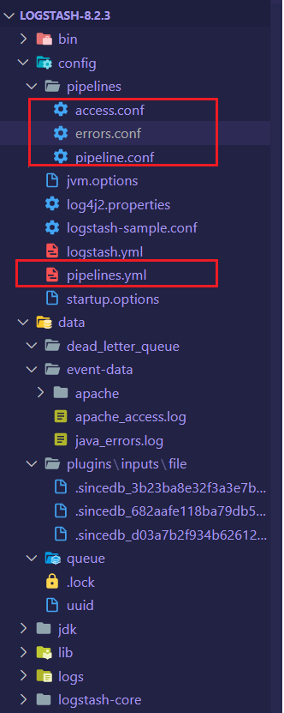

**Beats**

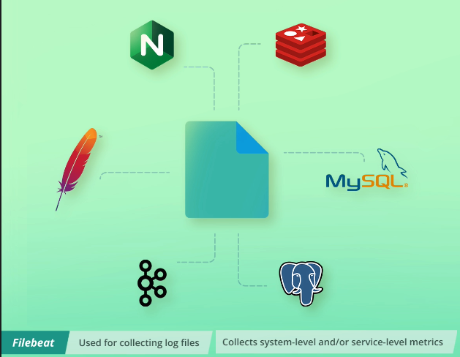

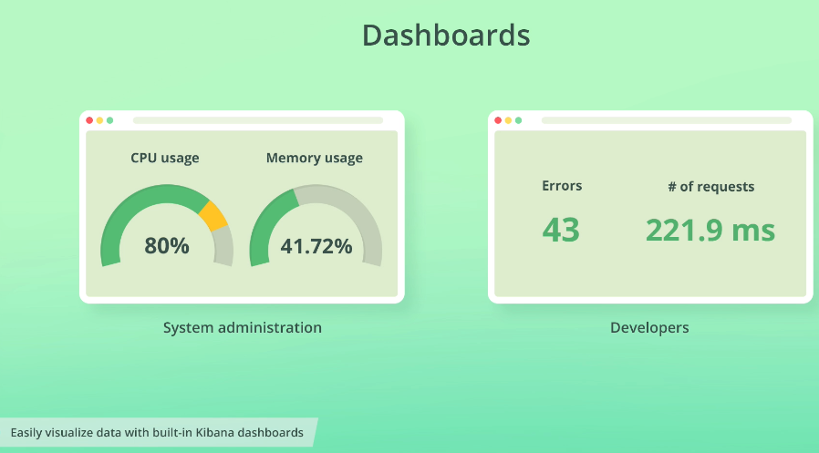

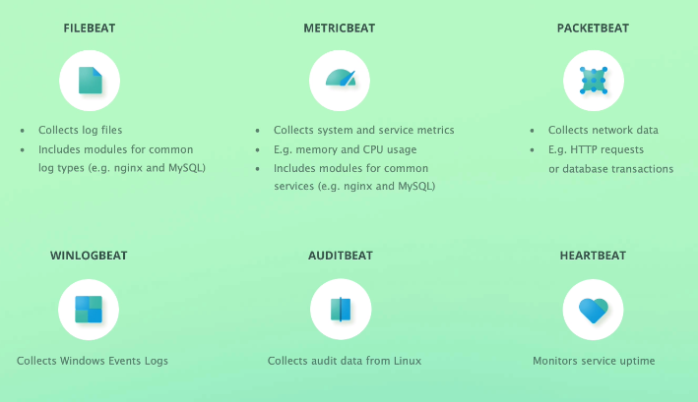

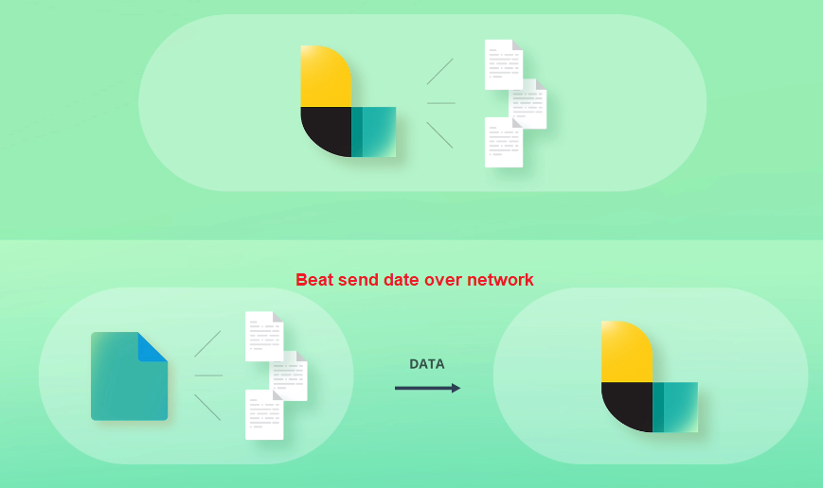

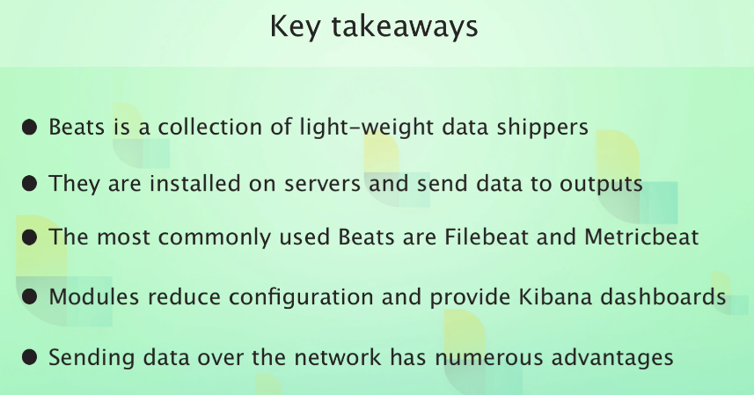

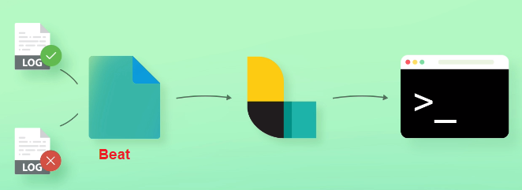

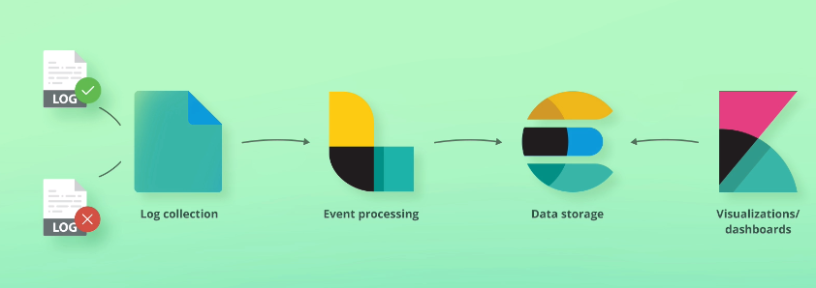

All information about configuration is in file filebeat-8.3.1-windows-x86_64\**filebeat.reference.yml**

The config file is filebeat-8.3.1-windows-x86_64\**filebeat.yml**

We comment the config of elasticsearch and enable Logstash output

Edit filebeat-8.3.1-windows-x86_64\**filebeat.yml**

*# ---------------------------- Elasticsearch Output ----------------------------*

*#output.elasticsearch:*

*# Array of hosts to connect to.*

*# hosts: ["localhost:9200"]*

*# Protocol - either `http` (default) or `https`.*

*#protocol: "https"*

*# Authentication credentials - either API key or username/password.*

*#api_key: "id:api_key"*

*#username: "elastic"*

*#password: "changeme"*

*# ------------------------------ Logstash Output -------------------------------*

output.logstash:

*# The Logstash hosts*

  hosts: ["localhost:5044"]

*# Optional SSL. By default is off.*

*# List of root certificates for HTTPS server verifications*

*#ssl.certificate_authorities: ["/etc/pki/root/ca.pem"]*

*# Certificate for SSL client authentication*

*#ssl.certificate: "/etc/pki/client/cert.pem"*

*# Client Certificate Key*

*#ssl.key: "/etc/pki/client/cert.key"*

**Enabling the apache module**

In terminal

# ./filebeat modules enable apache

Enabled apache

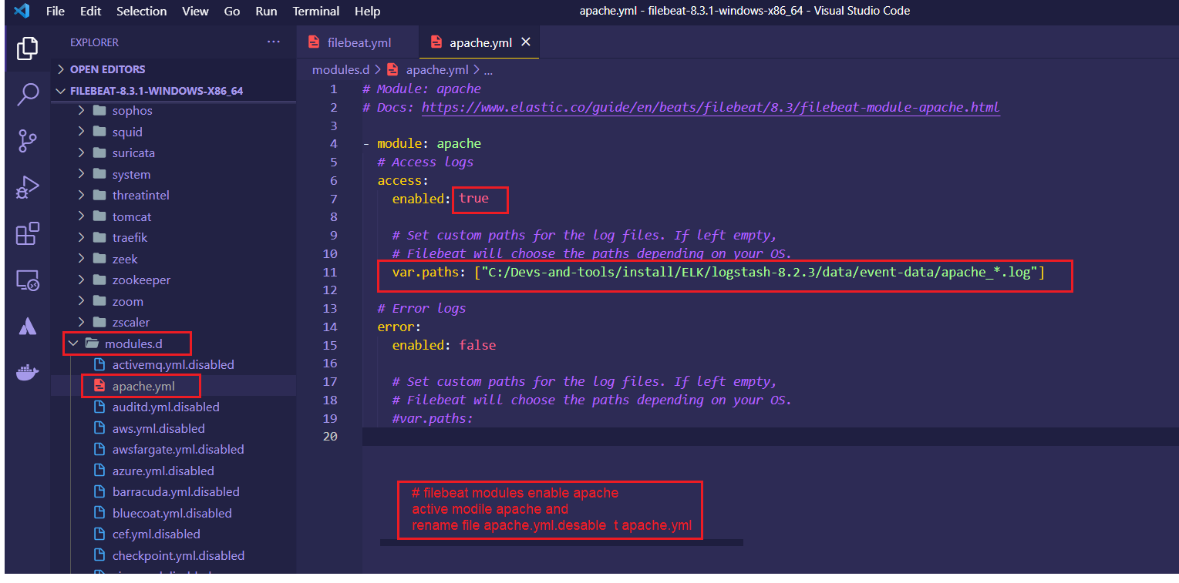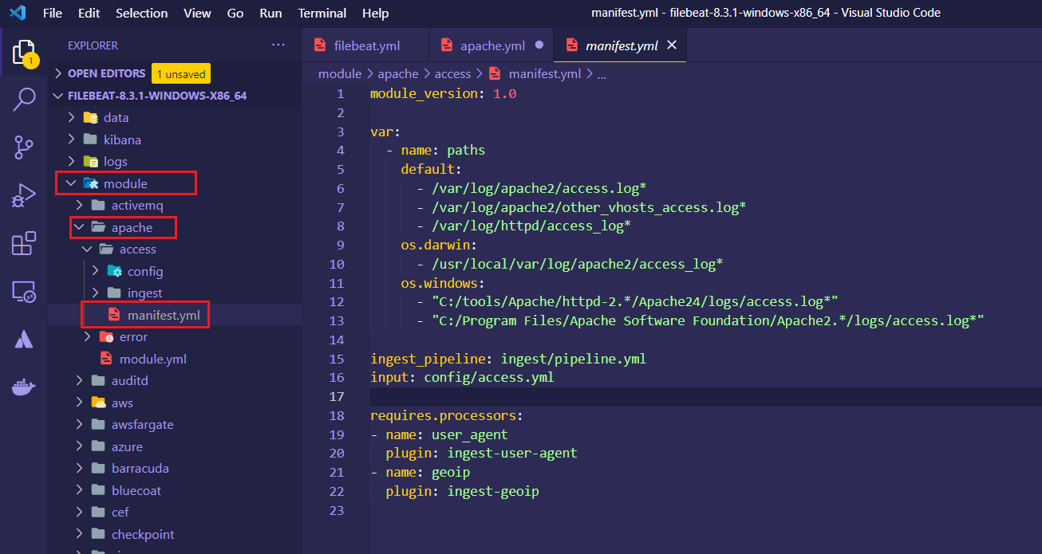

**Preparing a simple Logstash pipeline**

In logstash-8.2.3\config\pipelines.yml

Add pipepline

- pipeline.id: access_logs

*#pipeline.batch.size: 125*

  path.config: "C:\\Devs-and-tools\\install\\ELK\\logstash-8.2.3\\config\\pipelines\\access.conf"

config access.conf

input {

    beats {

        port => 5044

        host => "0.0.0.0"

    }

}

output {

    stdout {

        codec => rubydebug {

            metadata => true

        }

    }

}

Start logstash

# bin\logstash --config.reload.automatic

2022-12-26T21:38:58,630][INFO ][logstash.agent ] Successfully started Logstash API endpoint {:port=>9600, :ssl_enabled=>false}

[2022-12-26T21:39:00,297][INFO ][org.reflections.Reflections] Reflections took 469 ms to scan 1 urls, producing 120 keys and 395 values

[2022-12-26T21:39:02,461][INFO ][logstash.javapipeline ] Pipeline `access_logs` is configured with `pipeline.ecs_compatibility: v8` setting. All plugins in this pipeline will default to `ecs_compatibility => v8` unless explicitly configured otherwise.

[2022-12-26T21:39:02,691][INFO ][logstash.javapipeline ][access_logs] Starting pipeline {:pipeline_id=>"access_logs", "pipeline.workers"=>4, "pipeline.batch.size"=>125, "pipeline.batch.delay"=>50, "pipeline.max_inflight"=>500, "pipeline.sources"=>["C:/Devs-and-tools/install/ELK/logstash-8.2.3/config/pipelines/access.conf"], :thread=>"#<Thread:0x3f36c158 run>"}

[2022-12-26T21:39:04,444][INFO ][logstash.javapipeline ][access_logs] Pipeline Java execution initialization time {"seconds"=>1.74}

[2022-12-26T21:39:04,499][INFO ][logstash.inputs.beats ][access_logs] Starting input listener {:address=>"0.0.0.0:5044"}

[2022-12-26T21:39:04,560][INFO ][logstash.javapipeline ][access_logs] Pipeline started {"pipeline.id"=>"access_logs"}

[2022-12-26T21:39:04,913][INFO ][logstash.agent ] Pipelines running {:count=>1, :running_pipelines=>[:access_logs], :non_running_pipelines=>[]}

[2022-12-26T21:39:05,015][INFO ][org.logstash.beats.Server][access_logs][4d93c3fc7a89d931b86e86a1b507aff51edc7b1bdb5d255d2834edc619a1c163] Starting server on port: 5044

**Starting up Filebeat and processing logs**

-e : sending error log instead sending error.log , it s very useful for development

# ./filebeat -e

**Adding the elasticsearch index template**

**Load the Elasticsearch index template**

<https://www.elastic.co/guide/en/beats/filebeat/current/filebeat-template.html#load-template-manually>

**First method**

# ./filebeat setup --index-management -E output.logstash.enabled=false -E output.elasticsearch.hosts=["localhost:9200"]

**Second method (Load the index template manually)**

# ./filebeat export template > filebeat.template.json

In the same folder

# curl -XPUT -H 'Content-Type: application/json' http://localhost:9200/_index_template/filebeat-8.2.1 -d@filebeat.template.json

The solution is to add Content-Type: application/json header

curl -XPUT 'localhost:9200/_template/template_1' \

-H 'Content-Type: application/json' \

-d '**your query**'

This command override the configuration by disabling logstash output and setup config to connect to elasticsearch

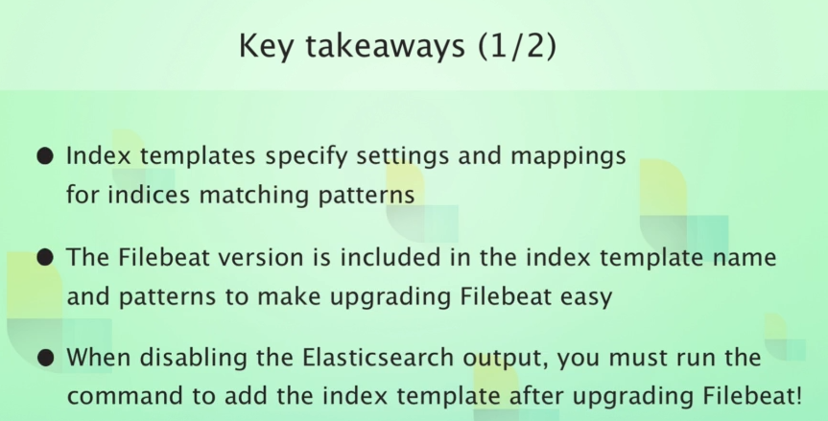

**Adding Kabana dashboards**

Edit filebeat.yml

Un coming host

*# =================================== Kibana ===================================*

*# Starting with Beats version 6.0.0, the dashboards are loaded via the Kibana API.*

*# This requires a Kibana endpoint configuration.*

setup.kibana:

*# Kibana Host*

*# Scheme and port can be left out and will be set to the default (http and 5601)*

*# In case you specify and additional path, the scheme is required: http://localhost:5601/path*

*# IPv6 addresses should always be defined as: https://[2001:db8::1]:5601*

  host: "localhost:5601"

*# Kibana Space ID*

*# ID of the Kibana Space into which the dashboards should be loaded. By default,*

*# the Default Space will be used.*

*#space.id:*

And execute this command

# ./filebeat setup –dashboards

Or change value in filebeat.yml

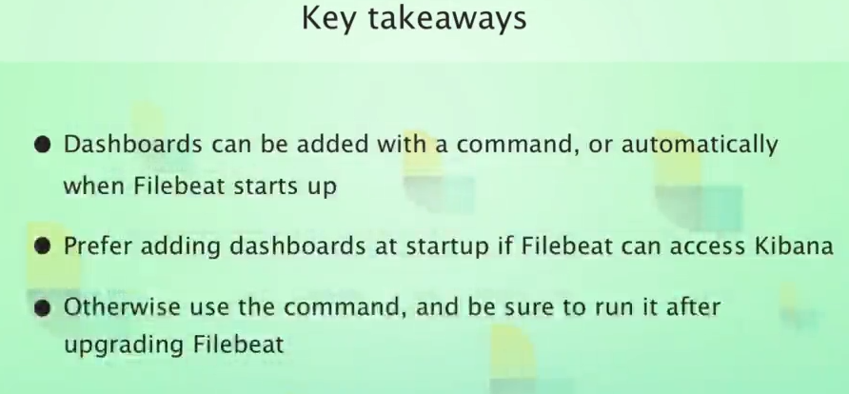

**Finishing up the pipeline**

Add file logstash/config/pipelines/access-log-filebeat.conf with this content

input {

beats {

port => 5044

host => "0.0.0.0"

}

}

filter {

if [event][module] != "apache" {

drop { }

}

if [event][dataset] == "apache.access" {

grok {

match => {

"message" => [

"%{IPORHOST:[source][address]} - %{DATA:[user][name]} \[%{HTTPDATE:[apache][access][time]}\] \"%{WORD:[http][request][method]} %{DATA:[url][original]} HTTP/%{NUMBER:[http][version]}\" %{NUMBER:[http][response][status_code]:long} (?:%{NUMBER:[http][response][body][bytes]:long}|-)( \"%{DATA:[http][request][referrer]}\")?( \"%{DATA:[user_agent][original]}\")?",

"%{IPORHOST:[source][address]} - %{DATA:[user][name]} \[%{HTTPDATE:[apache][access][time]}\] \"-\" %{NUMBER:[http][response][status_code]:long} -",

"\[%{HTTPDATE:[apache][access][time]}\] %{IPORHOST:[source][address]} %{DATA:[apache][access][ssl][protocol]} %{DATA:[apache][access][ssl][cipher]} \"%{WORD:[http][request][method]} %{DATA:[url][original]} HTTP/%{NUMBER:[http][version]}\" %{NUMBER:[http][response][body][bytes]:long}"

]

}

remove_field => "message"

}

if "_grokparsefailure" in [tags] {

drop { }

}

grok {

match => {

"[source][address]" => "^(%{IP:[source][ip]}|%{HOSTNAME:[source][domain]})$"

}

}

mutate {

add_field => { "[event][created]" => "%{@timestamp}" }

}

date {

match => [ "[apache][access][time]", "dd/MMM/yyyy:H:m:s Z" ]

remove_field => "[apache][access][time]"

}

useragent {

source => "[user_agent][original]"

target => "ua_tmp"

add_field => {

"[user_agent][device][name]" => "%{[ua_tmp][device]}"

"[user_agent][os][name]" => "%{[ua_tmp][os_name]}"

}

}

# OS version ECS compatibility

if [ua_tmp][os_major] {

mutate {

add_field => {

"[user_agent][os][version]" => "%{[ua_tmp][os_major]}"

}

}

if [ua_tmp][os_minor] {

mutate {

replace => {

"[user_agent][os][version]" => "%{[user_agent][os][version]}.%{[ua_tmp][os_minor]}"

}

}

if [ua_tmp][os_patch] {

mutate {

replace => {

"[user_agent][os][version]" => "%{[user_agent][os][version]}.%{[ua_tmp][os_patch]}"

}

}

if [ua_tmp][os_build] {

mutate {

replace => {

"[user_agent][os][version]" => "%{[user_agent][os][version]}.%{[ua_tmp][os_build]}"

}

}

}

}

}

mutate {

add_field => {

"[user_agent][os][full]" => "%{[user_agent][os][name]} %{[user_agent][os][version]}"

}

}

}

# User agent version ECS compatibility

if [ua_tmp][major] {

mutate {

add_field => {

"[user_agent][version]" => "%{[ua_tmp][major]}"

}

}

if [ua_tmp][minor] {

mutate {

replace => {

"[user_agent][version]" => "%{[user_agent][version]}.%{[ua_tmp][minor]}"

}

}

if [ua_tmp][patch] {

mutate {

replace => {

"[user_agent][version]" => "%{[user_agent][version]}.%{[ua_tmp][patch]}"

}

}

if [ua_tmp][build] {

mutate {

replace => {

"[user_agent][version]" => "%{[user_agent][version]}.%{[ua_tmp][build]}"

}

}

}

}

}

}

mutate {

remove_field => ["ua_tmp"]

}

geoip {

source => "[source][ip]"

target => "[source][geo]"

}

} else if [event][dataset] == "apache.error" {

grok {

match => {

"message" => [

"\[%{APACHE_TIME:[apache][error][timestamp]}\] \[%{LOGLEVEL:[log][level]}\]( \[client %{IPORHOST:[source][address]}\])? %{GREEDYDATA:[message]}",

"\[%{APACHE_TIME:[apache][error][timestamp]}\] \[%{DATA:[apache][error][module]}:%{LOGLEVEL:[log][level]}\] \[pid %{NUMBER:[process][pid]:long}(:tid %{NUMBER:[process][thread][id]:long})?\]( \[client %{IPORHOST:[source][address]}\])? %{GREEDYDATA:[message]}"

]

}

pattern_definitions => {

"APACHE_TIME" => "%{DAY} %{MONTH} %{MONTHDAY} %{TIME} %{YEAR}"

}

}

date {

match => [ "[apache][error][timestamp]", "EEE MMM dd H:m:s yyyy", "EEE MMM dd H:m:s.SSSSSS yyyy" ]

remove_field => "[apache][error][timestamp]"

}

grok {

match => {

"[source][address]" => "^(%{IP:[source][ip]}|%{HOSTNAME:[source][domain]})$"

}

}

geoip {

source => "[source][ip]"

target => "[source][geo]"

}

}

}

output {

elasticsearch {

hosts => "localhost"

manage_template => false

index => "%{[@metadata][beat]}-%{[@metadata][version]}-%{+YYYY-MM-dd}"

}

}

In logstash/config/pipelines.yml add the pipeline access-log-filebeat.conf

- pipeline.id: access_logs

#pipeline.batch.size: 125

path.config: "C:\\Devs-and-tools\\install\\ELK\\logstash-8.2.3\\config\\pipelines\\access.conf"

- pipeline.id: access_logs_filebeat

#pipeline.batch.size: 125

path.config: "C:\\Devs-and-tools\\install\\ELK\\logstash-8.2.3\\config\\pipelines\\**access-logs-filebeat.conf**"

start filebeat

# ./filebeat -E

ECS = Elasticsearch common schema

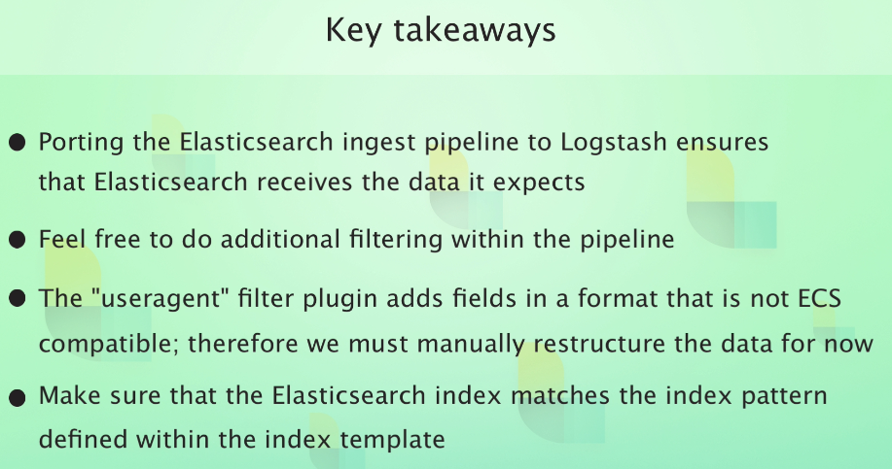

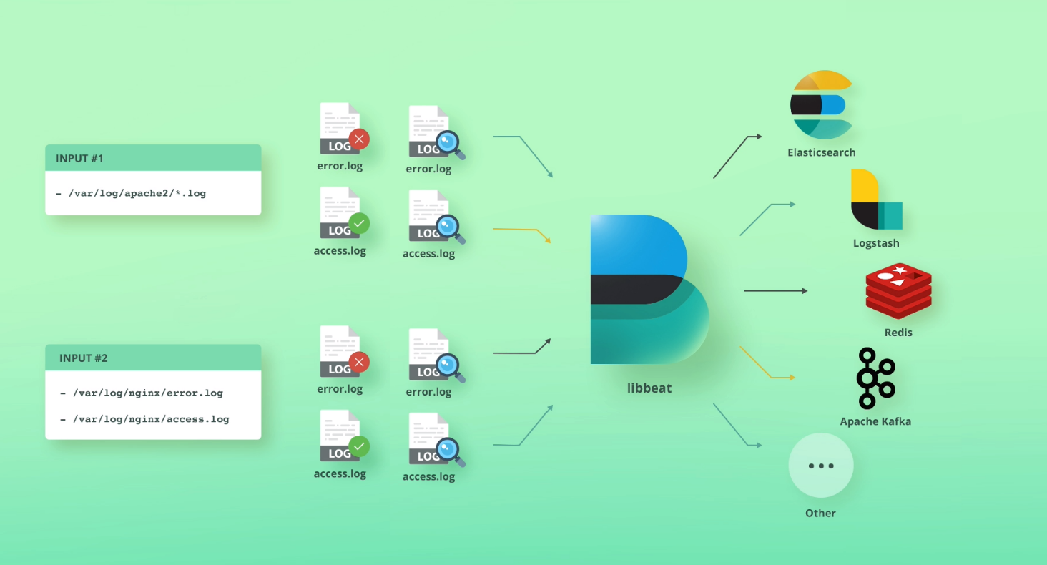

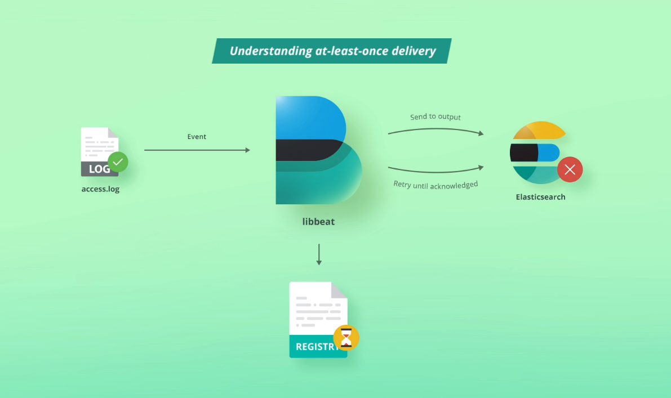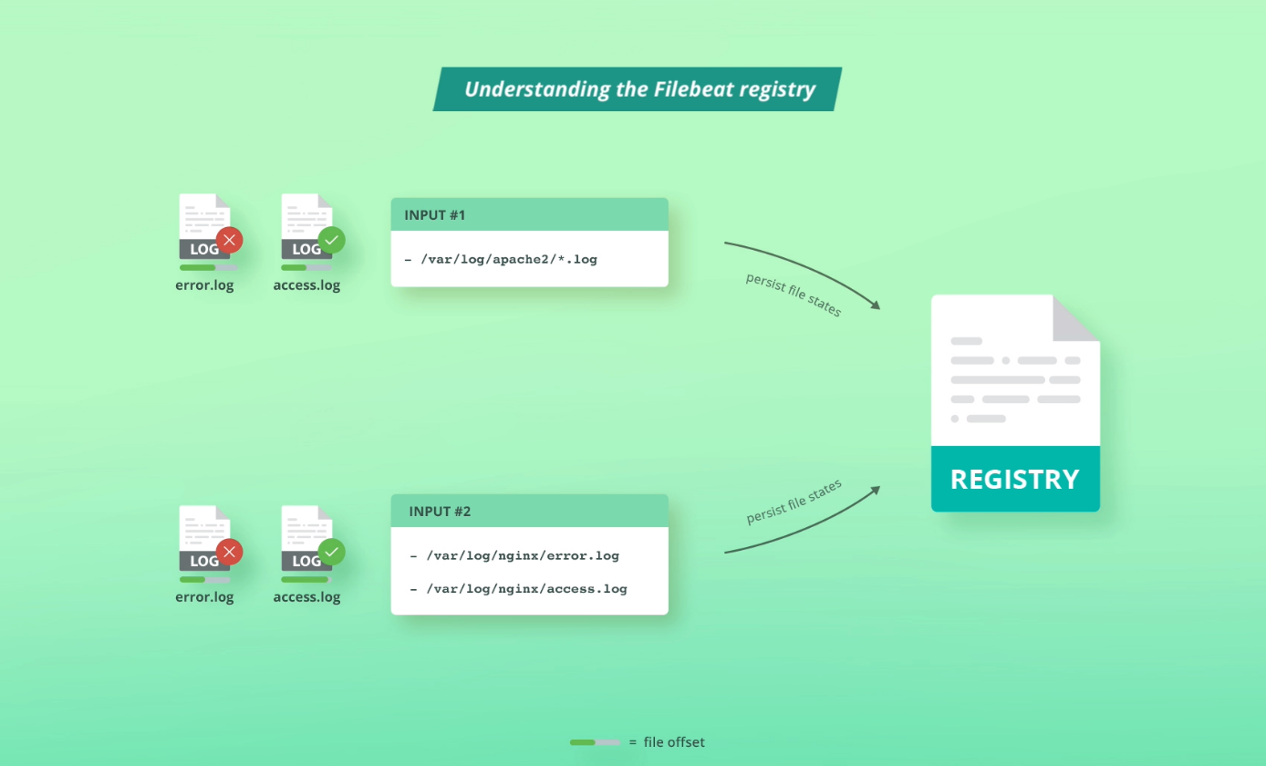

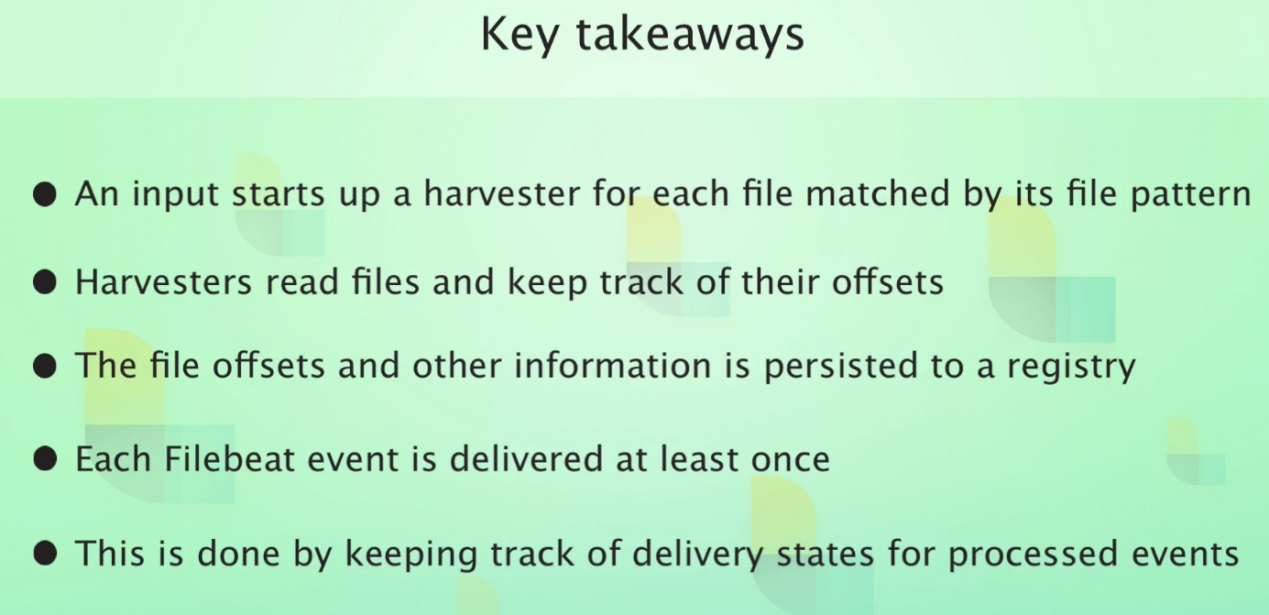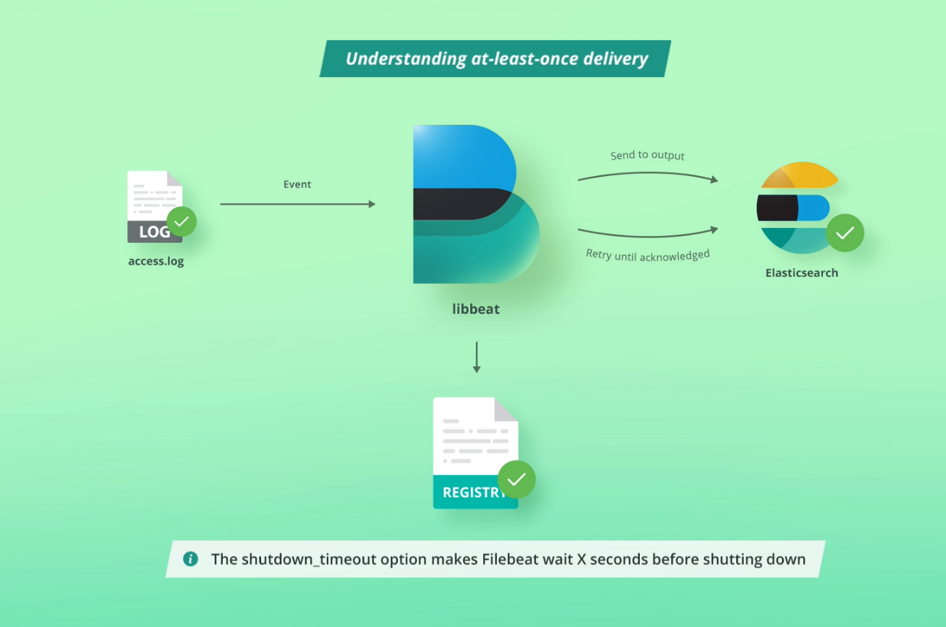

**Register**

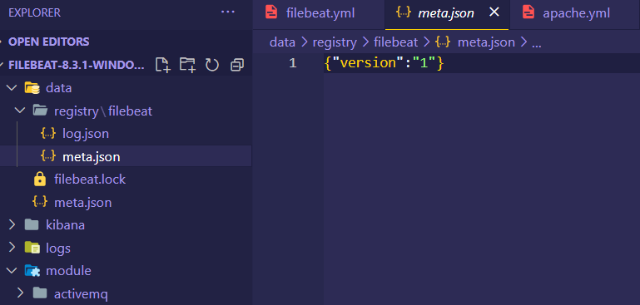

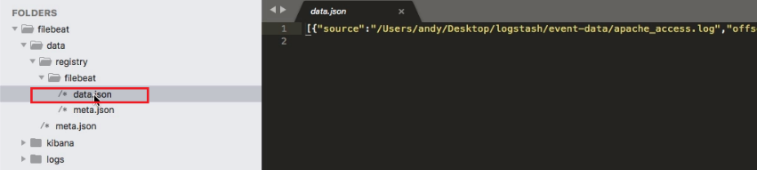

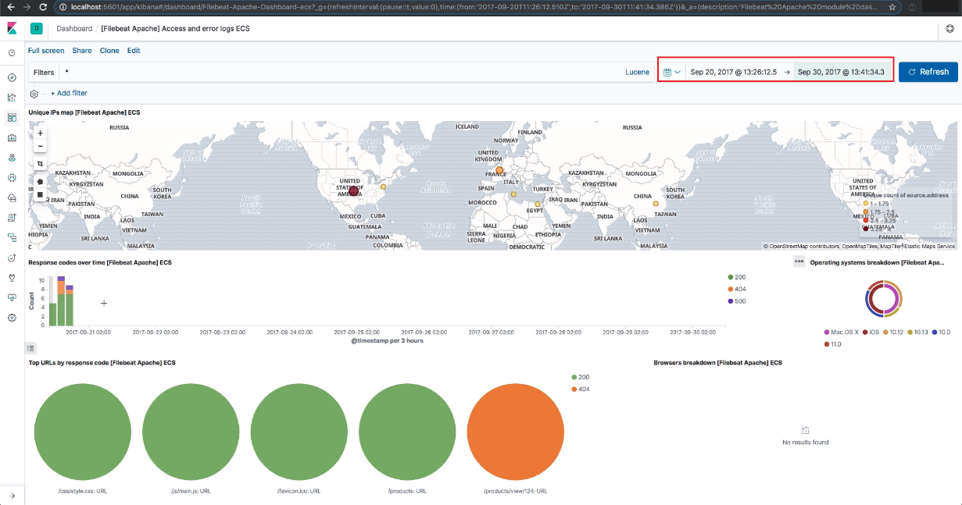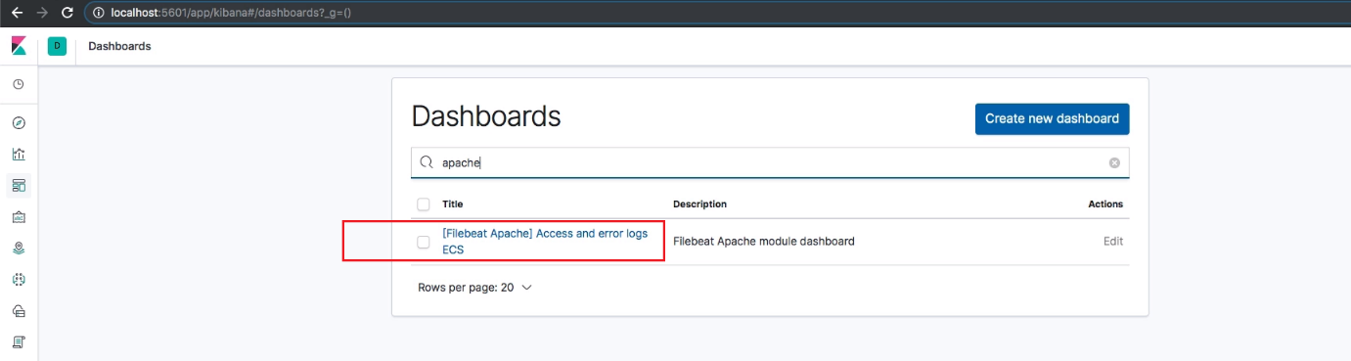

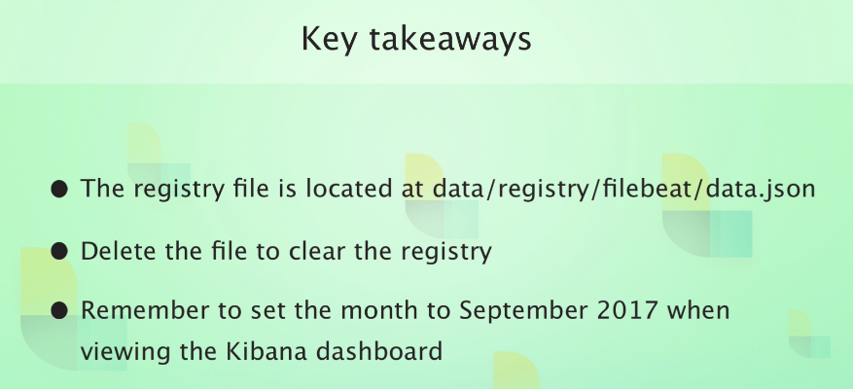

**Processing more access log**

In kibana delete all indeces of filebeate

# DELETE /filebeat-*

Change de file module.d/apache.yml to take all logs

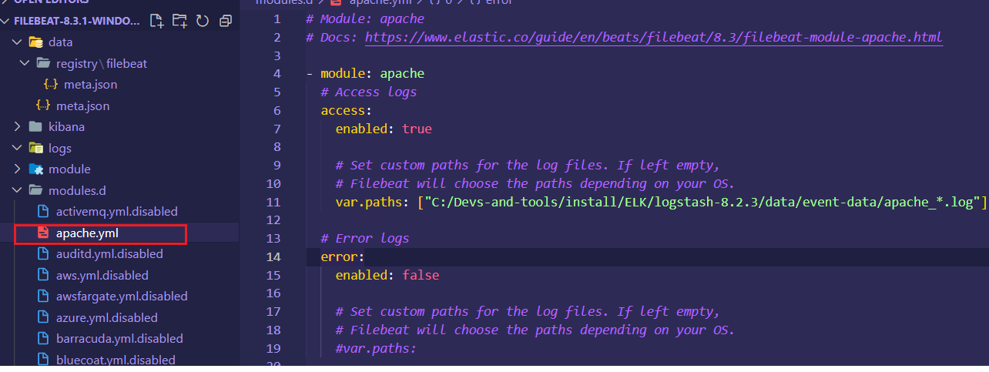

To do manual input configuration

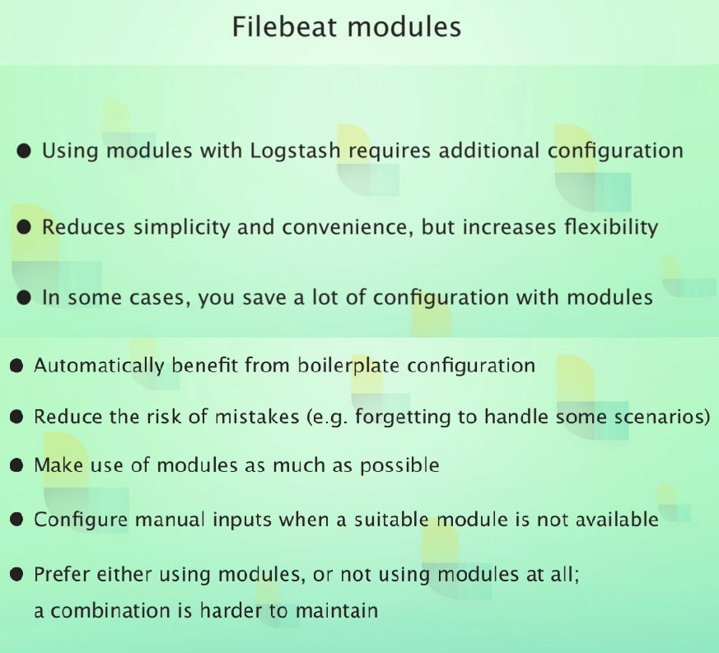

**Tags Events**

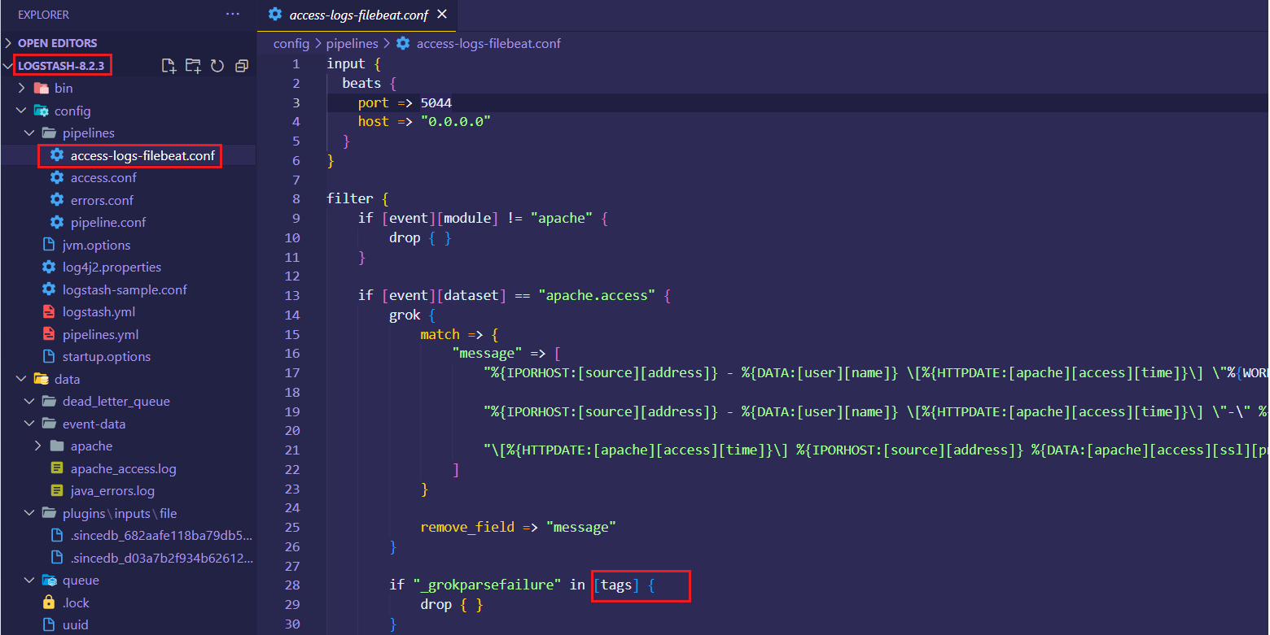

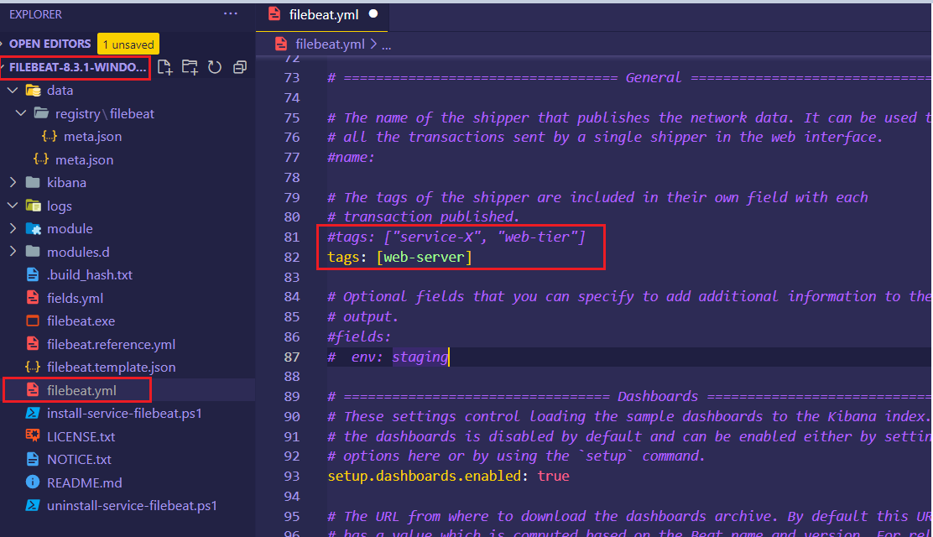

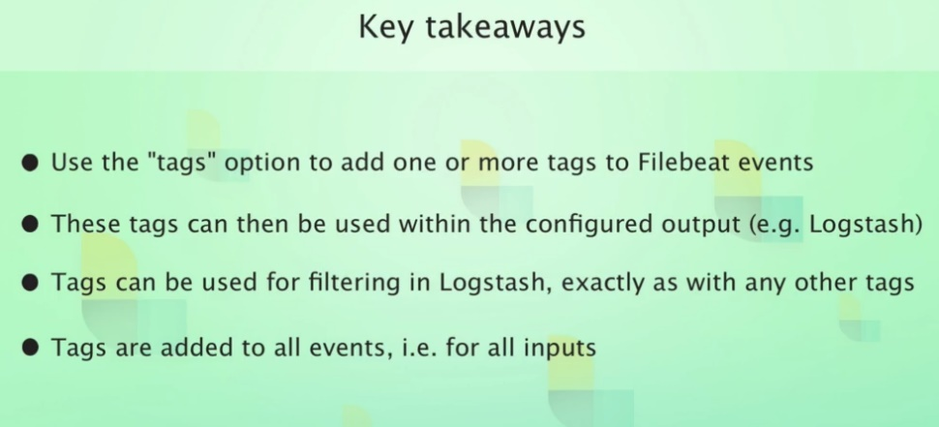

**Approaches for handling multiple log types**

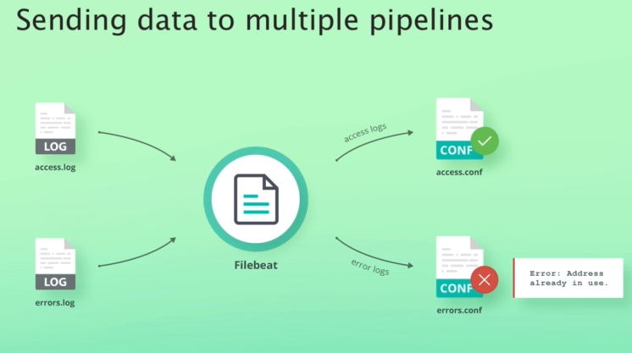

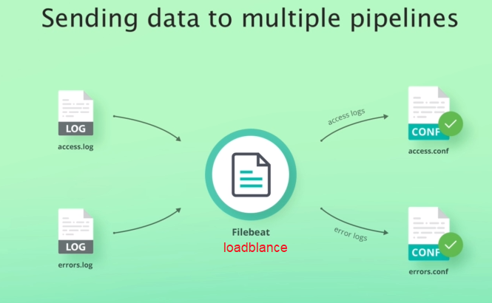

<https://www.elastic.co/guide/en/beats/filebeat/current/load-balancing.html>

output.logstash:

hosts: ["localhost:5044", "localhost:5045"]

loadbalance: true

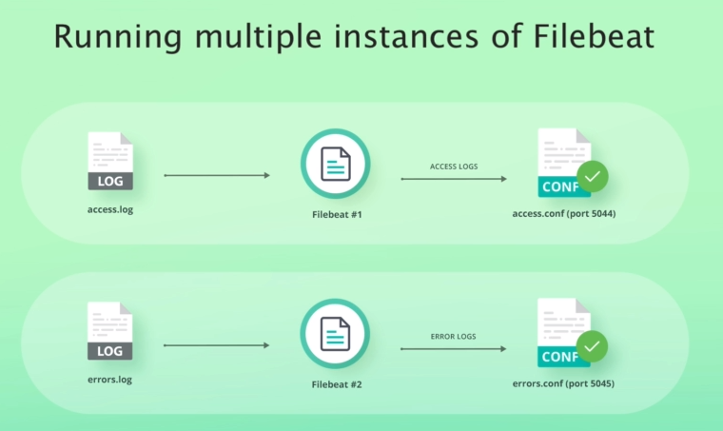

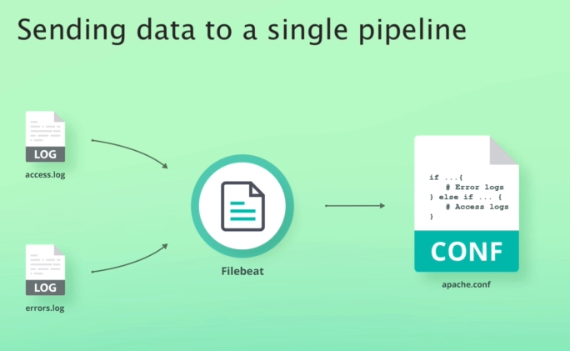

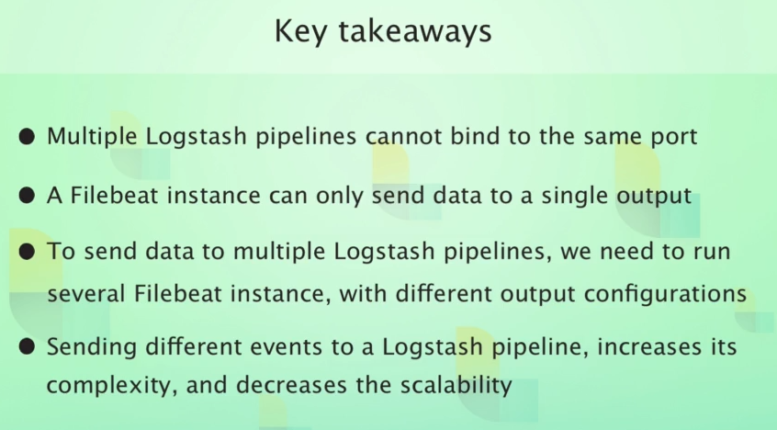

**Processing Apache error Logs**

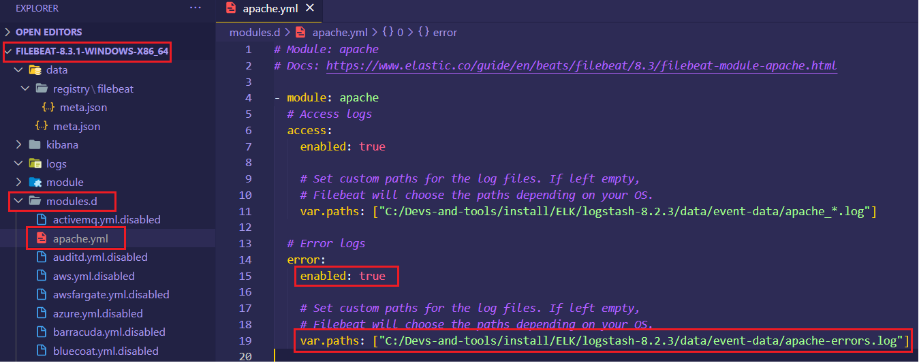# ./filebeat module enable apache

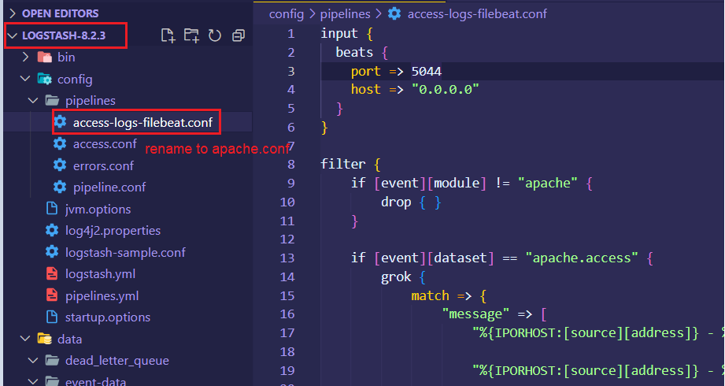

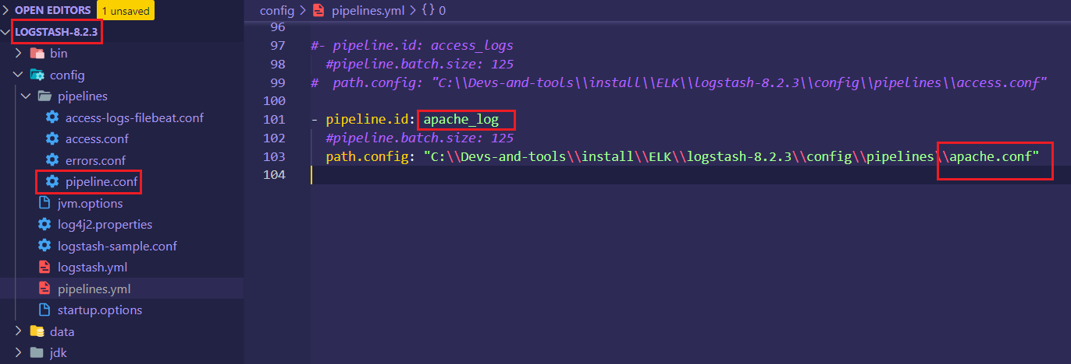

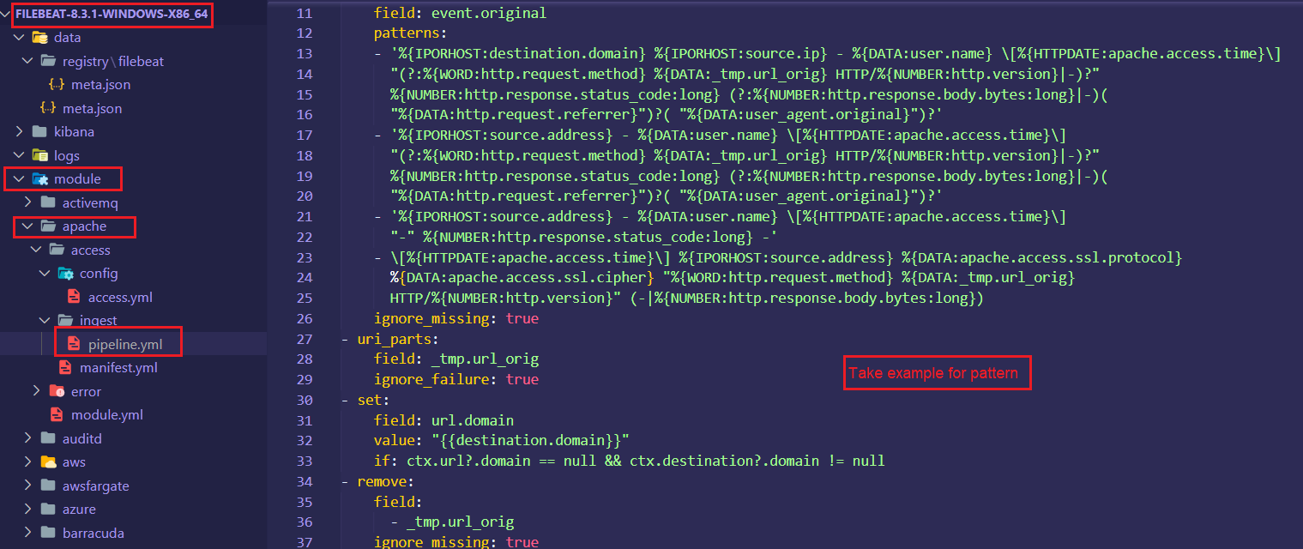

Grok is a super set of regular expression

Modify file logstash-8.2.3/config/pipelines/apache.conf

input {

  beats {

    port => 5044

    host => "0.0.0.0"

  }

}

filter {

    if [event][module] != "apache" {

        drop { }

    }

    if [event][dataset] == "apache.access" {

        grok {

            match => {

                "message" => [

                    "%{IPORHOST:[source][address]} - %{DATA:[user][name]} \[%{HTTPDATE:[apache][access][time]}\] \"%{WORD:[http][request][method]} %{DATA:[url][original]} HTTP/%{NUMBER:[http][version]}\" %{NUMBER:[http][response][status_code]:long} (?:%{NUMBER:[http][response][body][bytes]:long}|-)( \"%{DATA:[http][request][referrer]}\")?( \"%{DATA:[user_agent][original]}\")?",

                    "%{IPORHOST:[source][address]} - %{DATA:[user][name]} \[%{HTTPDATE:[apache][access][time]}\] \"-\" %{NUMBER:[http][response][status_code]:long} -",

                    "\[%{HTTPDATE:[apache][access][time]}\] %{IPORHOST:[source][address]} %{DATA:[apache][access][ssl][protocol]} %{DATA:[apache][access][ssl][cipher]} \"%{WORD:[http][request][method]} %{DATA:[url][original]} HTTP/%{NUMBER:[http][version]}\" %{NUMBER:[http][response][body][bytes]:long}"

                ]

            }

            remove_field => "message"

        }

        if "_grokparsefailure" in [tags] {

            drop { }

        }

        grok {

            match => {

                "[source][address]" => "^(%{IP:[source][ip]}|%{HOSTNAME:[source][domain]})$"

            }

        }

        mutate {

            add_field => { "[event][created]" => "%{@timestamp}" }

        }

        date {

            match => [ "[apache][access][time]", "dd/MMM/yyyy:H:m:s Z" ]

            remove_field => "[apache][access][time]"

        }

        useragent {

            source => "[user_agent][original]"

            target => "ua_tmp"

            add_field => {

                "[user_agent][device][name]" => "%{[ua_tmp][device]}"

                "[user_agent][os][name]" => "%{[ua_tmp][os_name]}"

            }

        }

*# OS version ECS compatibility*

        if [ua_tmp][os_major] {

            mutate {

                add_field => {

                    "[user_agent][os][version]" => "%{[ua_tmp][os_major]}"

                }

            }

            if [ua_tmp][os_minor] {

                mutate {

                    replace => {

                        "[user_agent][os][version]" => "%{[user_agent][os][version]}.%{[ua_tmp][os_minor]}"

                    }

                }

                if [ua_tmp][os_patch] {

                    mutate {

                        replace => {

                            "[user_agent][os][version]" => "%{[user_agent][os][version]}.%{[ua_tmp][os_patch]}"

                        }

                    }

                    if [ua_tmp][os_build] {

                        mutate {

                            replace => {

                                "[user_agent][os][version]" => "%{[user_agent][os][version]}.%{[ua_tmp][os_build]}"

                            }

                        }

                    }

                }

            }

            mutate {

                add_field => {

                    "[user_agent][os][full]" => "%{[user_agent][os][name]} %{[user_agent][os][version]}"

                }

            }

        }

*# User agent version ECS compatibility*

        if [ua_tmp][major] {

            mutate {

                add_field => {

                    "[user_agent][version]" => "%{[ua_tmp][major]}"

                }

            }

            if [ua_tmp][minor] {

                mutate {

                    replace => {

                        "[user_agent][version]" => "%{[user_agent][version]}.%{[ua_tmp][minor]}"

                    }

                }

                if [ua_tmp][patch] {

                    mutate {

                        replace => {

                            "[user_agent][version]" => "%{[user_agent][version]}.%{[ua_tmp][patch]}"

                        }

                    }

                    if [ua_tmp][build] {

                        mutate {

                            replace => {

                                "[user_agent][version]" => "%{[user_agent][version]}.%{[ua_tmp][build]}"

                            }

                        }

                    }

                }

            }

        }

        mutate {

            remove_field => ["ua_tmp"]

        }

        geoip {

            source => "[source][ip]"

            target => "[source][geo]"

        }

    } else if [event][dataset] == "apache.error" {

        grok {

            match => {

                "message" => [

                    "\[%{APACHE_TIME:[apache][error][timestamp]}\] \[%{LOGLEVEL:[log][level]}\]( \[client %{IPORHOST:[source][address]}\])? %{GREEDYDATA:[message]}",

                    "\[%{APACHE_TIME:[apache][error][timestamp]}\] \[%{DATA:[apache][error][module]}:%{LOGLEVEL:[log][level]}\] \[pid %{NUMBER:[process][pid]:long}(:tid %{NUMBER:[process][thread][id]:long})?\]( \[client %{IPORHOST:[source][address]}\])? %{GREEDYDATA:[message]}"

                ]

            }

            pattern_definitions => {

                "APACHE_TIME" => "%{DAY} %{MONTH} %{MONTHDAY} %{TIME} %{YEAR}"

            }

        }

        date {

            match => [ "[apache][error][timestamp]", "EEE MMM dd H:m:s yyyy", "EEE MMM dd H:m:s.SSSSSS yyyy" ]

            remove_field => "[apache][error][timestamp]"

        }

        grok {

            match => {

                "[source][address]" => "^(%{IP:[source][ip]}|%{HOSTNAME:[source][domain]})$"

            }

        }

        geoip {

            source => "[source][ip]"

            target => "[source][geo]"

        }

    }

}

output {

  elasticsearch {

    hosts => "localhost"

    manage_template => false

    index => "%{[@metadata][beat]}-%{[@metadata][version]}-%{+YYYY-MM-dd}"

  }

}

Run logstash

Run filebeat

**Handling multiline logs**

<https://www.elastic.co/guide/en/beats/filebeat/current/multiline-examples.html>

log java

Option muliline

